Molecular Ecology Chaps 0-3 UnShiny

John Wares

5/26/2021

# 0. What is this?

Written by **J.P. Wares**, Professor, University of Georgia, jpwares [at] uga.edu

This is shared *by-nc-sa/4.0*, I’m not writing it to be some polished final thing but something that shifts through new ideas and new people using or modifying parts of it. This text may be used following these guidelines: <https://creativecommons.org/licenses/by-nc-sa/4.0/>

This document is being developed for the cross-listed ECOL/GENE 4530/6530 at University of Georgia to improve the experiential nature of learning the methods necessary for the field of “*molecular ecology*”. Maintaining it as an .Rmd allows direct analytical opportunities (and familiarity with basic statistical coding approaches) and the ability to incorporate some simple simulation tools using Shiny. It will also let me update as needed in a straightforward way.

## 0.1 Why write this?

### For most of my career as a biologist, I’ve found myself wanting to know *why things are where they are*. That means I need to know **what** they are, and how they can move; rules like chess but far more complex and varied, and sometimes involving low probabilities. I need to know these things with varying degrees of precision given the questions being asked about those organisms. The ‘molecular ecology’ approaches we will learn and evaluate in here have helped a lot with this pursuit, but of course it all roots in knowing as much as you can about the organisms - life history, ecology, development and maturation - otherwise.

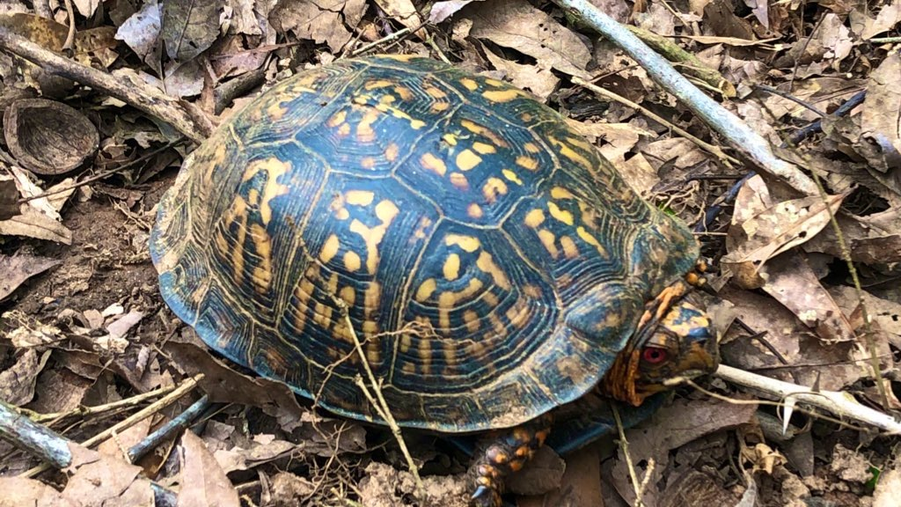

…

**Surely you already have some thoughts on how turtles move, and what that could mean for the spatial distribution of diverse phenotypes and molecular diversity within their range? (photo: J. Wares)**

## 0.2 Why would I use this?

I *think*… I think… I’m writing this in a way that more advanced students can skim the first few chapters and gain something from focusing on the latter ones; a more novice course might only get through the first several chapters and then just read appropriate-focused papers (e.g. in the undergrad/grad mix I expect to teach, the course will move at one pace but the grads at another and with a distinct type of guidance, starting to use more time later in semester to present on methods or case studies). I want to think about how to *teach* molecular ecology, not just about how to do it. It seems there has to be some coding expertise that comes into play at this point, and some experiential practice. So, I think this is what is going to work. I hope.

# 1. Introduction

The first day of classes we will prep our computers for using R/RStudio for a major resource in this class. If at all possible, before the class begins you should install R:

<https://www.r-project.org>

and RStudio (free version):

<https://rstudio.com/products/rstudio/>

Please note the risk in all of this is that *packages* and *versions* of software are constantly changing, and sometimes code that has been working will stop (and vice-versa) because of these changes. Additionally, a key element of making this work - currently - is making sure that the *path* is set correctly so that this .Rmd file can find figures and code to interact with. I’m hoping I’ve set this up so that everything works from the directory you downloaded, but we will double-check today.

## 1.0 R Markdown and Shiny

This is an R Markdown document, with Shiny apps built in. At this point in time, the Shiny apps are all written by the talented Dr. Silas Tittes and are available at <https://github.com/silastittes/shiny_popgen>.

What does that mean? Markdown is a simple formatting syntax for authoring HTML, PDF, and Microsoft Word documents. For more details on using R Markdown see <http://rmarkdown.rstudio.com>. Adding the Shiny apps means that the document is *interactive*. The only downside is that it means that users must have **R** and **RStudio** installed, plus a few R packages, on their computer.

(OK, another downside is it is going to be difficult to read in a hammock. Or, at least, you should read something else if you are in a hammock.)

The upside is that it is more of a living document. It means that as data change, the output of analysis can change. It also means that R code can be built directly into the document so that you can see how some figures or modules are generated, and you can build on this knowledge. You can embed an R “code chunk” like this:

library(learnPopGen)  
driftplot<-drift.selection(p0=0.25,Ne=500,w=c(1,1,1),ngen=400,nrep=5)

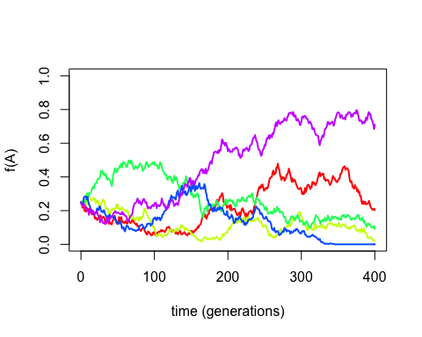

I’m putting this text together using R Markdown in particular so that examples can be incorporated that students can then work with to try and understand how varying the input information affects our expectations about the molecular data used to answer ecological questions. For example, the code chunk above - and the figure it produces - not only illustrates *genetic drift* (here, an example where one of 2 alleles is initiated in a population at a frequency of 0.25, and the “effective population size” about which we will learn more, is 500; there are 5 replicate simulations - in fact you should notice that the figure is distinct every time you run this document!), but actually provides the code for the illustration that can be modified as knowledge of the process becomes more advanced (when looking at the R Markdown code document itself in *RStudio*, if you hit the green ‘play’ button in the upper right corner of the “code chunk” you can do the simulation over and over, and you can look at the code and probably figure out quickly how to change the parameters it runs under).

By organizing this material the way I think it may come across to beginning students in the field, I hope to avoid the personal puzzle of when I initially shifted this class from 8000-level (intermediate grad course) to 4000-level (advanced undergrads with fewer prerequisites) by clarifying these probabilistic processes with illustrations based on simulations that the students can themselves repeat.

Because I’m using **Shiny** code, you cannot “Knit” this document into a static form, but instead will hit “Run Document” (up near the top of the RStudio screen) once it is loaded into R and that will generate a browser text that is dynamic in some places to let *you* run the simulations. It is a work in progress, but for now it does mean that to work with this you must have access to a computer that will run R and RStudio, at a minimum.

This will be less a textbook that you read for complete comprehension, and more something you read to generate questions that we discuss; I am trying to “flip the classroom” and organize for future classes at the same time. Some aspects will need to be explained in class or using diverse media to make sense. When I was a sophomore learning cell biology, I know that I tested well on the subject but in the end, had zero clue what gel electrophoresis meant until I did it on a daily basis. (super basic intro to “electrophoresis”: <https://www.youtube.com/watch?v=ZDZUAleWX78>) So, **your job is to ask questions!** That way, we learn more completely not just from me, but from each other and from our inquiry.

For other users of this document, please note: I use a lot of examples I am familiar with, meaning they are often projects I’m an author on, or was on that person’s committee, or whatever. There is so much other *fantastic* science out there, this isn’t about ego though: it’s just my ability to immediately dig deeper with those as examples not just of how the science *can* be done, but also about when it *could have been done better*. Also, I’m a marine ecologist; when I talk about plants, it is basically because of great colleagues who have entranced me with their weird and important terrestrial photosynthetic life, and mammals and fish similarly: I credit cool colleagues who have brought me into the fold. If you end up using this as an instructor, I encourage you to think about including your own, even better, examples.

Plus, I can imagine now I can just look in here for some of the papers I want others to refer to, you know - what was that paper I cited about XXXXXX? Oh yeah it was in chapter 4…

## 1.1 What is Molecular Ecology?

The phrase ‘molecular ecology’ is nothing new; it is in many ways synonymous with ‘ecological genetics’ as first applied by pioneers like Dobzhansky, Ford, and others (en.wikipedia.org/wiki/Molecular_ecology). Maybe the question of terminology comes down to people *who identify as geneticists but want to solve ecological concerns* (Phil Hedrick and his work on Florida panthers in 1995? I’ve not met him to verify how he identifies as a scientist), or people *who identify as ecologists but recognize how to use genomic data as a means to greater understanding* (can’t help my bias, I think of Rick Grosberg doing a number of deep explorations into behavioral ecology via understanding genome-wide kinship, see Fig 1.1). The journal ***Molecular Ecology*** (<https://onlinelibrary.wiley.com/journal/1365294x>) began in 1991; the field is not new, but the attention given to it from a broader spectrum of scientists seems to be. Before giving an overview of what may be included in this topic, it is probably first important to acknowledge that there are “molecular” approaches to addressing ecological questions that are often *not* included in this field.

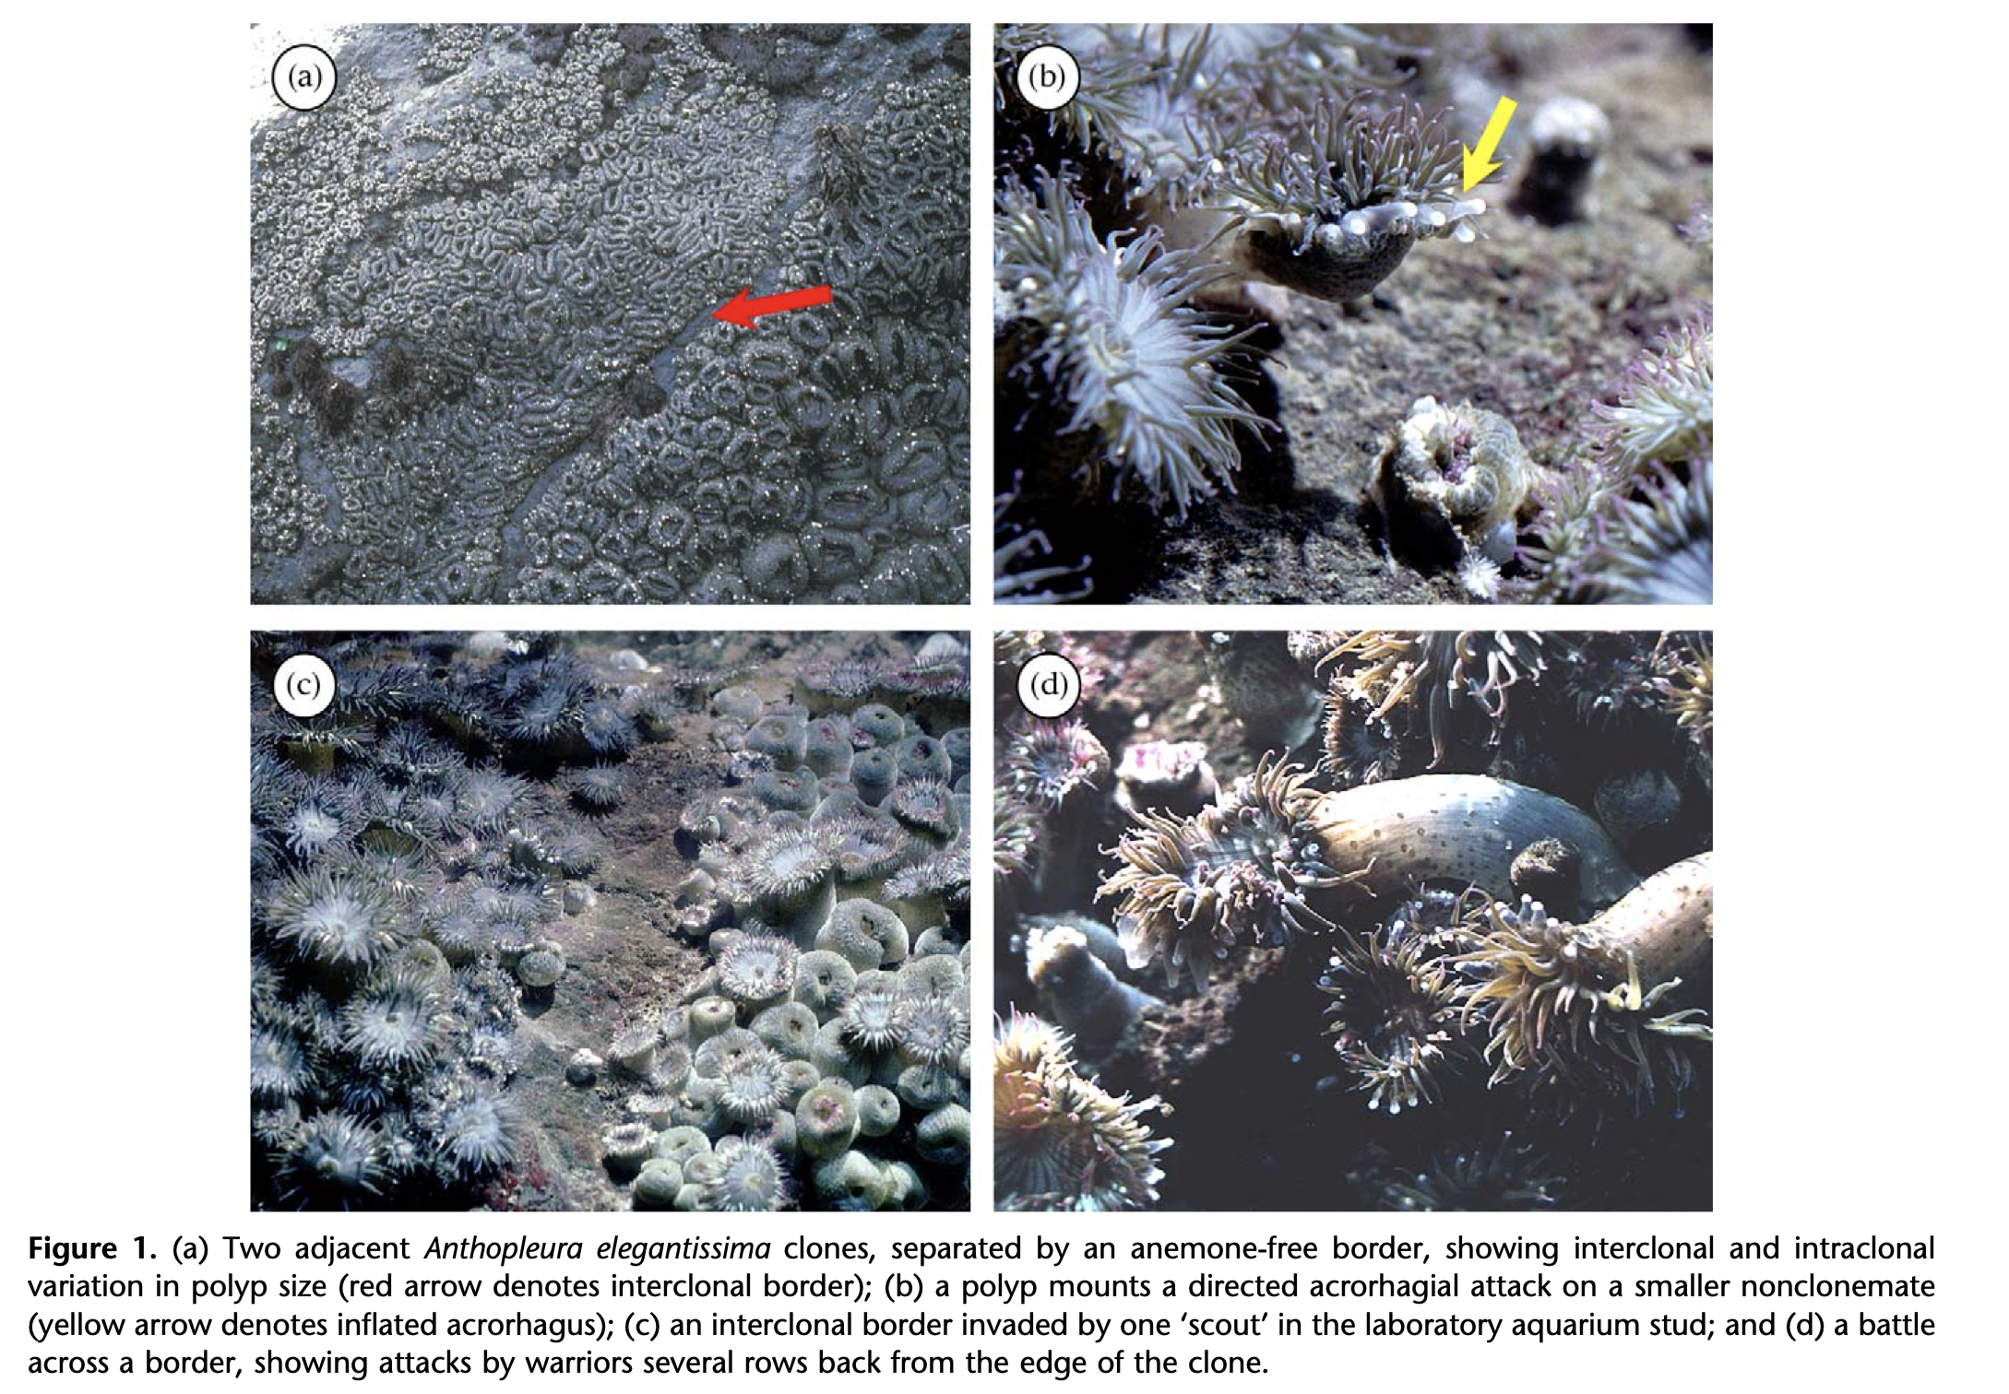

**Fig.1.1 - A figure from Ayres & Grosberg (2005,** [**doi:10.1016/j.anbehav.2004.08.022**](doi:10.1016/j.anbehav.2004.08.022)**), title starting “Behind anemone lines…” about how anemones interact based on their relatedness - they do not have to have identical genomes to interact cooperatively, but have to share allelic diversity above a certain threshold at several genomic loci - otherwise they fight.**

Ecosystem ecologists ask about elemental and nutrient cycles in the environment, and such work routinely screens for the abundance, provenance, and isotopic ratios of Carbon, Nitrogen, Phosphorus, and other key elements to life (<https://en.wikipedia.org/wiki/Ecosystem_ecology>). A good example might be the work of Dr. Krista Capps on invasive suckermouth catfish (family Loricariidae) in Mexico; these catfish have bony plates on their body that absorb tremendous amounts of phosphorus from the rivers they are in - limiting algal growth and thus indirectly harming the resources for native fishes. Certainly, a molecular component to ecology! Also, the chemical analysis of otoliths and gastropod shells (e.g. <https://www.pnas.org/content/116/14/6878>), or assessment of paleoenvironments via analysis of gas composition in ice cores or otherwise (<https://www.wm.edu/news/stories/2019/for-chesapeake-oysters,-the-way-forward-leads-backback-through-the-fossil-record.php>), are ‘molecular’ approaches to answering ecological questions.

However, this is where we return to that phrase ‘ecological genetics’, which puts our field squarely in connection with how heritable information - DNA, RNA, and proteins - can be studied to evaluate the relationships of organisms as a means of considering migration, isolation, population demography, mating and kinship analysis, and more. These questions can only be addressed because of evolution of the molecules in question. **Mutations** occur and may be passed on through reproduction; as mutations become common in a population, they become the basis of the markers we track to address such questions using population genetic understanding of evolutionary mechanisms such as **drift**, **non-random mating**, **selection**, and **migration**.

Thus, this text will follow some basic outlines that you may find in other books like Joanna Freeland’s *Molecular Ecology* 3rd ed (2020) or Matt Hahn’s *Molecular Population Genetics* (2019), excellent resources in distinct ways - however, since I often work across many resources in an attempt to save students some money, and each of these texts is aimed at a slightly distinct target audience, this is going to give us the basic framework for exploring heritable molecular diversity in a way that keeps the focus primarily on the ecological questions and contemporary ways to make inference from DNA, RNA, or comparable data. Also, I am going to deviate from typical texts in this field in one way in particular - I won’t be delving as much into the historical development of the field, which has often served as the organizing framework, e.g. as markers advance our analyses have advanced. I’m going to argue *that is not true*; we are actually using fairly traditional population genetic analyses these days with more data, and better data; the periods of using other methods (e.g. the heyday of “phylogeography”) were actually being used as *proxies* for population genetic theory (Templeton, Avise).

Finally, I’ll note something I’m trying out in terms of verbiage. For a long time, people have talked about population *genetics* and conservation *genetics* and ecological *genetics.* However, with part of my appointment being in a Department of *Genetics*, I can see that for the most part we are not asking questions about how diversity is inherited or the cellular processes that interact as much as we are about how the diversity across a genome (or portions of it), and how it is distributed, indicate the evolutionary and ecological processes acting on it. This applies to early work in *Drosophila pseudoobscura* and chromosome rearrangements straight through to modern RAD-seq approaches and whole-genome resequencing. The distinction between “genetics” and “genomics” is not, to me, about the precise number of markers you are studying but in the intent of analysis. I may not want to know anything about the identity of a gene that is an outlier in terms of cytonuclear disequilibria, because I don’t want to resolve how a nuclear gene and a mitochondrial gene are interacting. That is for somebody else. The fact that they interact gives each of them special identity in helping us see patterns that are driven by the environment and interactions with the environment, and so **the patterns are for us**. It’s a distinction that is open for discussion of course.

## 1.2 Overall structure, a work in progress…

**Chapter 2** will deal with how molecular markers are generated (What are molecular markers - extending to diploid and to cost-effective ways to explore genomes, what do they cost in time and money, and what sampling guidelines should we consider? Some elements of sampling won’t make sense until we get into the types of inference and analysis used with particular questions, so in some places these will be left as questions for us to return to), and how they can be applied using barcoding, environmental DNA, and community ordination to understand distribution and abundance.

**Chapter 3** will provide additional grounding in how mutations and diversity are generated - pretty key, especially for students with less exposure to introductory genetics coursework.

**Chapter 4** is about the basic elements of alpha and beta diversity – that is, the diversity at a single location and the difference in diversity across locations. As ecology is often focused on the distribution and abundance, these approaches let us more accurately define the prevalence of certain subsets of biodiversity so we can more accurately assign locations to distinct communities or systems. The ‘space for time’ argument applies both ecologically and genetically through the process of drift *at a minimum* (Hubbell, Vellend) so that we expect different locations to have different diversity in part because they are demographically independent; of course migration (and gene flow) will affect this and that is one of our major goals to understand in this field.

**Chapter 5 and 6** deal with basic evolutionary mechanisms and what they can do to molecular diversity; Generalizable population models and how to tell when the data indicate a more complex model, e.g. ***HWE and the coalescent***; an overview on finite population size: Ne and all the distinct ways it is measured, WHY IT AFFECTS DIVERGENCE RATE, and all the distinct ways it is only kind-of useful, from Hare et al 2011 (and Waples before him) to human evolution and even taking a swing at Turner et al 2002 and Alo et al 2004 (which is more likely correct given the distinctions). We will talk about population models, mutation accumulation and biogeography to get at $μ$, basic info on movement in the sea based on genomic diversity and so on, what we know of recombination, and this all lets us get to …

**Chapter 7** where we deal somewhat with how knowing this baseline information helps us think about what selection does across distinct environments. This is often a target for research, but it takes so much baseline information to really understand outlier molecular diversity.

That sets us up for **Chapter 8** which gets into quantitative genetics and the association with genomic data, because what we know of selection is that many traits are super polygenic. We will discuss and work with RNA expression data, learn a bit about epigenomic markers as well, and discuss ‘keystone loci’ that have effects on the ‘extended phenotype’ of populations.

**Chapter 9** will give us time to explore mating and behavior - collective as well as individual.

**Chapter 10** deals with where the field is going and spends some time focusing on the ‘natural history awareness’ of the analyses we have learned; often key insights come from seeing how data behave or misbehave given your preconceptions.

*N.B.* I am aiming this at upper-level undergrads in ecology or evolutionary biology who may have had some introductory genetics or evolution; but, I am going to do my best to not assume you remember everything from those classes. Beginning grad students will also benefit, but should be encouraged to lead the class in paper discussions or experiential workshops to help build their depth of understanding.

Also, with this being written in the work-at-home era of **COVID**, some references will be scant pointers to the actual resource and I hope you will forgive me when I know who I’m pulling from but can’t find it right away.

**Week 1 reading:**

Travis (2020): <https://www.journals.uchicago.edu/doi/pdfplus/10.1086/708765>

Marmeisse et al. 2013 <https://nph.onlinelibrary.wiley.com/doi/epdf/10.1111/nph.12205> to think about what molecular tools can tell us about diversity and ecosystem function

Govindarajan et al. 2015 <https://peerj.com/articles/926/#> to consider how divergence of populations (tree thinking) illuminates divergence of function, tolerances, or interactions; distribution and dispersal; and first look at summary statistics in molecular ecology in terms of barcode gaps/distinctions

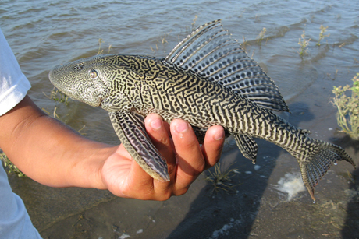

**Fig.1.2 - A pleco caught in the Chacamax River in Chiapas, Mexico - photo credit Krista Capps.**

*To wrap this up, a photo of one of the invasive Loricariid catfish mentioned earlier. More info on the system can be found at* [*https://news.cornell.edu/stories/2013/08/freeing-pet-catfish-can-devastate-ecosystems*](https://news.cornell.edu/stories/2013/08/freeing-pet-catfish-can-devastate-ecosystems) *. Can you think of how studying genomic diversity of these catfish - as well as the source populations from which they come - could be useful?*

*Resources cited in this section - I will typically cite in-line actually*

Avise 2000

Ayres & Grosberg (2005, <doi:10.1016/j.anbehav.2004.08.022>)

Freeland, J. 2020.

Hahn, M.W. 2019.

Hedrick, P.W. 1995.

Templeton, A.R. (NCA era)

*** don;t forget the experiential stuff *** text: experiential appendix: poppr, barcoding, rad data, etc I think what we have here is Chapter 1 is for first day of class, assign some reading to be discussed in week 2 of class. Chapter 2 easily encompasses some lecture, some Geneious, some reading/discussion time and thus more than just 2 days of the class.

# 2. Sampling the ‘simplest’ genomic data

I’m going to start this text in a very different place than I’ve started teaching this class before; I have tended to start at the beginning and work through the history to reach the present. My efforts at re-organizing my class in 2020 led me to see this as a funny choice. For one, it means we may spend some time talking about methods that are currently DOA, even if we learned a lot from them at the time. At this point, there is simply no reason for me to re-hash AFLP markers (I won’t even define the acronym). Even the most in-vogue methods of 2020 will not be as exciting in 5 years. But our efforts to learn this material should be generic to the specific means of obtaining data, anyway.

Additionally, I’ve recognized that some applications of molecular data have been treated as distinct, and separated in other texts or in previous versions of my class, even though their basic methodology aligns pretty clearly with understanding some simple basics about DNA sequence data and how it evolves within and among populations of biodiversity. I hope that is clear from this first data-focused chapter, which itself raises some questions about how we observe and quantify patterns of diversity in nature.

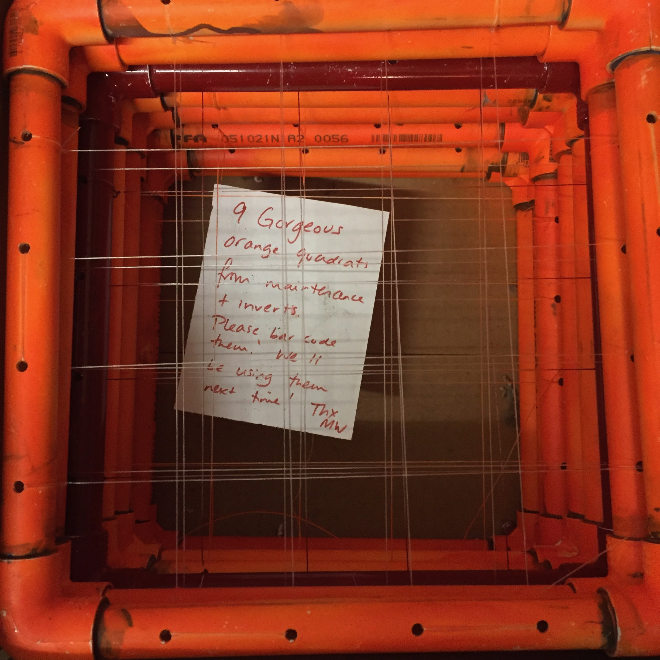

**Fig.2.1 - 9 gorgeous orange quadrats, photo credit J. Wares but quadrats and note thanks to Dr. Marjorie Wonham, I believe.**

## 2.1. Our sampling effort

If you aren’t familiar with a *quadrat*, the photo above (Figure 2.1) includes “9 gorgeous orange quadrats” and you may quickly deduce that these are nothing more than PVC squares with grids installed using heavy fishing line, and the whole thing spray painted orange so they can be easily found in an intertidal marine habitat with sprawling macroalgae and dark rock coves studded with limpets. A *quadrat* is a means to sample spatial diversity that is commonly used by ecologists to estimate the diversity of a larger spatial domain, with the scale varying depending on the system one is looking at, the evenness in that system, and the type of diversity to be counted (and thus extrapolated to say something about the whole ecosystem).

So, what I often tell my students is that if you wanted to characterize the vegetation of your college campus, and you randomly tossed down a single quadrat of this size (~25cm across), what would you find? Maybe manicured lawn, maybe some flowering plants, maybe the root system of a single tree. You know that wouldn’t say much about the vegetation on your campus, so you would want to think about how to gain data from multiple quadrats before you made any characterization - and you would want to think about how randomly they are used (Anne Magurran’s *Measuring Biological Diversity* has some great insights into this problem).

Similarly, a single random anonymous DNA sequence from your species of interest may or may not represent well the genome as a whole, and may or may not be appropriate to answer your question. But first, to keep things simple, lets do exactly that. If you take a small sample of a genome - perhaps a single gene, or locus, that can be easily captured using modern molecular approaches like PCR or metabarcoding (**BOX B:** How molecular data are obtained). That means that it is on the order of 100s of nucleotides in length (long enough to capture variation in many instances), and we can *mostly* ignore biological recombination of this fragment (though PCR itself can promote the formation of chimeric, recombinant sequences - Katz et al. 2009)

(*so now you can imagine having some DNA sequences from several individuals - and we are thinking about the variation among those sequences*)

We are assuming that the same *homologous* sequence(s) can be obtained from other individual organisms or samples. In other words, whenever we make comparisons of two DNA sequences, we assume that they have a single common origin and the variation between them represents the mutation events that have happened since that point of common ancestry, whether we are comparing members of the same population or individuals from divergent species. This itself can be difficult; the more we know about genome structure, the more we know that many gene regions are duplicated and lost through time, so that some gene regions will have multiple, *paralogous* copies in the same genome, and counting the mutational events will be wrong if the contrast between molecules is specified incorrectly.

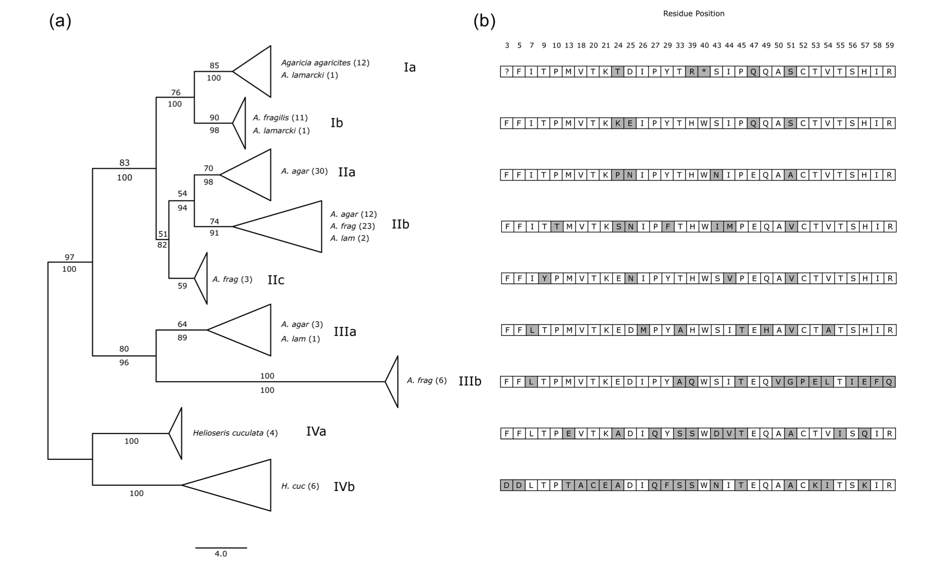

**Fig.2.2 - The same PCR primers amplify allelic (homologous) and distinct gene copy variation (paralogous) in fluorescent proteins of the coral *Agaricia*. Determining how to separate this diversity for the typical analytical approaches in the field of molecular ecology is not trivial in such cases. Note the distinct amino acid sequences resulting from the sequence diversity; one copy appears to be non-functional with a ‘stop’ codon in the middle of the domain. From Meyers, MK 2013 *J. Heredity*** [**doi:10.1093/jhered/est028**](doi:10.1093/jhered/est028)**.**

The problem of gene duplication can include whole genomes (polyploidy is common in plants, and has even generated new species in frogs) or just parts of a genome, and depending on how recent the evolutionary event was, it may be impossible to isolate parental-contributed diversity from the diversity found across copies. However, there are ways to analyze such data and we will discuss further as these instances come up. *For now we are only focusing on the gene sequences we can recover to represent natural diversity, and how to compare those sequences (not worrying about the combinations of copies within an individual).*

In addition, we assume that the individual nucleotides (A,C,T,G) in these DNA sequences being compared are homologous. This means *aligning* the sequences so that the variation we see in a single position - some sequences have a C, others have a T, for example - represent a single mutational event (more on this assumption later) rather than inadvertently comparing haphazard parts of that gene region. In Figure 2.3, a DNA sequence for a protein-coding region provides an example where it is clear that despite some nucleotide variation, each DNA sequence is coding for the same amino acid sequence. It would be unusual for so much similarity to exist among distinct genomic regions (though biology can throw plenty of improbable curveballs, some of them noted above), and we can evaluate this probabilistically (Altschul et al 1990).

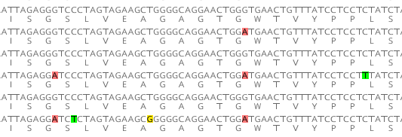

**Fig.2.3. DNA sequence alignment, with amino acids shown for protein sequence. The colored positions indicate mutational diversity where the less frequent variant is highlighted.**

Once these steps are complete - DNA sequences obtained from comparable parts of the genome, and aligned so that the mutational events are clear - we can start to make some simple assumptions about what the diversity among sequences means.

## 2.2 Genetic Distances and ‘Barcode Gaps’

From the DNA sequences in Figure 2.3, we can start making one of the first and most basic assessments of genetic distance between sequences or between collections of sequences. For example, the comparison between sequence 1 and sequence 2 (counting from the top) shows a single nucleotide difference between them (an A/G transition), out of 63 such site comparisons. If you are unfamiliar with how these data are shown, the nucleotide sequence includes only (A/C/T/G), and below each amino-acid-coding triplet the amino acid single-letter code is shown; in many cases we would compare sequences that are not protein coding (or for which we don’t care about the product) and so the amino acid sequence would not be shown.

From these data, we can estimate the distance *d* based on this proportion of differences between sequences, e.g. *d* = 1/63 = 0.0159. Then, comparing sequence 1 to sequence 3 there are no differences, so *d* = 0; and sequence 1 to sequence 4 represents *d* = 3/63 or 0.0476. You should be able to make similar calculations for all pairs of sequences in Figure 2.3. The R code below shows how to turn those genetic distances into a very basic histogram.

dist1<-c(0.0159,0,0.0476,0,0.0635,0.0159,0.0317,0.0159,0.0476,0.0476,0,0.0635,0.0476,0.0476,0.063)  
hist(dist1,breaks=4,col="darkred")

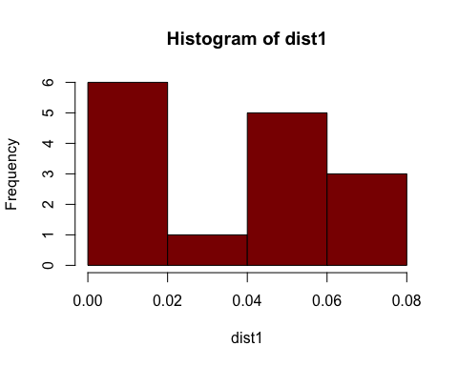

Now all of these pairwise distances are shown in a histogram, above, and in this case all of those sequences come from organisms sharing the same Latin binomial, *Chthamalus fragilis* (though later in this unit you will see it is more complicated than that). Imagine comparing these sequences with the sister species, *C. proteus*, by adding just a single additional set of comparisons between the 6 sequences above and a single one from *C. proteus*. The contrast can further be identified in our R histogram by coloring the bars in order; note the change in scale on the x-axis as we add more distantly related sequences. Yes, **R** friends, I know it can be done more efficiently. Bear with me, this section is basically unedited since I wrote in April 2020 as my class flipped to online during the beginning of **COVID**, but I want it to be clear where the outputs come from!

dist2<-c(0.0159,0,0.0476,0,0.0635,0.0159,0.0317,0.0159,0.0476,0.0476,0,0.0635,0.0476,0.0476,0.063,0.16,0.17,0.16,0.17,0.17,0.18)  
hiscols<-c("darkred","darkred","darkred","darkred","lightblue","lightblue","lightblue","lightblue","lightblue")  
hist(dist2,breaks=8,col=hiscols)

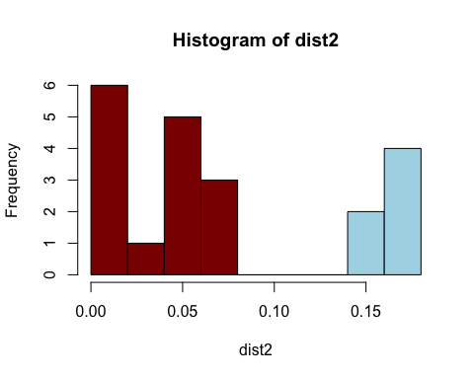

Now, we have recapitulated what is called the ‘barcode gap’, a classic figure below (2.4) from Meyer & Paulay (2005, <https://doi.org/10.1371/journal.pbio.0030422>). What this is suggesting is that though there is variation within species (in phenotype as well as sequence divergence), in many cases that variation is considerably less than the distinctions from other species (also known as distinct populations that are demographically isolated in some way).

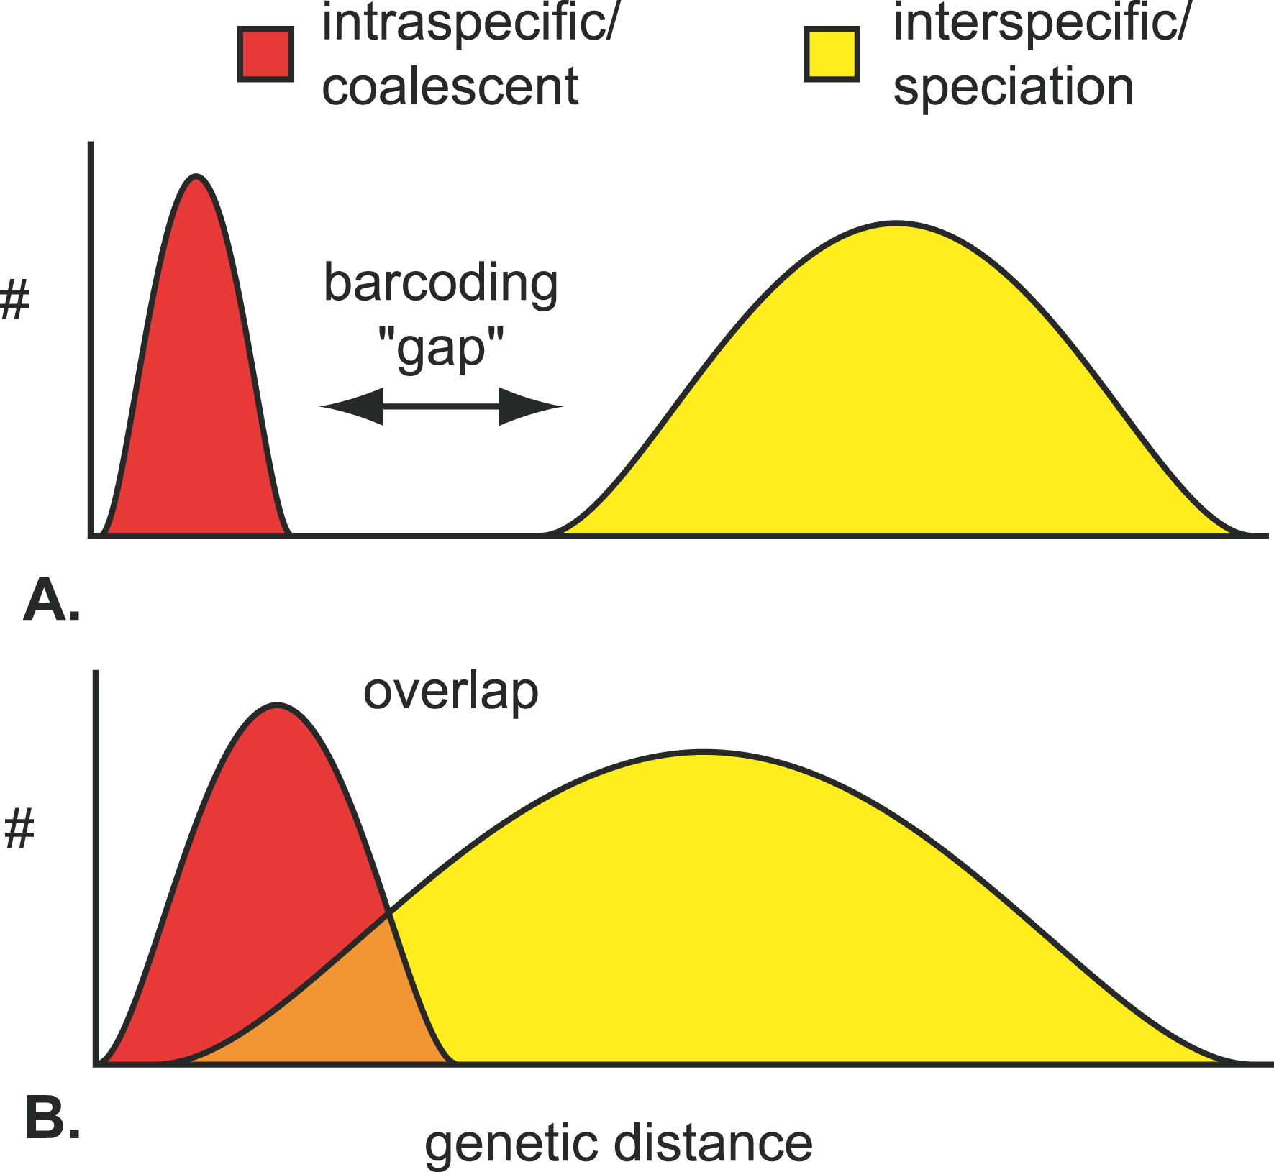

**Fig.2.4. Illustration of the idealized barcoding gap (top panel) for contrasting diversity within and between species; the bottom panel shows that sometimes it gets more complicated. Just ask folks who study corals…e.g. Tonya Shearer’s work.**

Why are we exploring this kind of diversity among DNA sequences? Well, our first goal as molecular ecologists may be simply to evaluate the distribution and abundance of diversity in and among sampled habitats. We can use the sequence data itself to identify *what* is found in a habitat, when this is a more effective approach than other forms of identification. For reasons that will become clearer as we learn more about the different modes of inheritance (natural history!) of gene regions, the “barcode gap” is most effectively evaluated with genes that (1) exhibit high mutational diversity, (2) are haploid, and (3) are uniparentally inherited; but it will work for any gene that provides sufficient resolution. For this reason, mitochondrial and chloroplast loci are often the first tools used for such surveys.

(note to flesh out: Microbial and barcode gap tend to rely on haploid low recombination otherwise complete dna so we start here for comparing.)

**Example 1. Some aspects of the focal diversity are well characterized.**

If we assume that the species are identifiable (at one life stage or another), and there is clearly greater genomic divergence between different species than between different individuals of the same species (the “barcode gap”), then with a reference library of representative individuals for each species we can use DNA sequencing to identify remaining unknown or hard-to-identify specimens. A great example comes from Katie Bockrath’s dissertation work on freshwater mussels (Unionidae). Though many freshwater biologists will laugh to read this sentence: lets assume that the adults can be clearly identified, sorted into species, and DNA can be sequenced from those individuals. Our real challenge lies with the larvae and the juveniles, which are themselves miniscule (hundreds of $μ$ m). Unionid mussels produce larvae (glochidia) that are obligate parasites on fish gills; they must developmentally transform on a fish to mature to the juvenile stage, when they are still quite small but drop off into the sediment to continue maturation.

There are a lot of complexities involved in this life cycle, and knowledge of which species are host-generalists versus specialists, that are beyond the question addressed here. However, Dr. Bockrath wanted to know *which* mussel species are using *which* fish species as hosts, which itself can influence how well individuals move via their host and how sustainable a population may be. In order to do this, fish gills were sampled for glochidia and the tiny (5-10mg) tissue samples collected. To ensure that PCR reactions are specific to the mussel and not the fish, Katie used her knowledge of the quirky life history of Unionids to target a relatively unique coding region in the mitochondrial control region (FORF; Breton et al.); this means that her PCR would not amplify fish DNA, only mussel DNA.

Because of the ‘barcode gap’ between the diversity found within a species, e.g. *Toxolasma pullus* and the diversity found in other species (or other genera) like *Elliptio icterina*, Katie was able to assign each tissue sample - as minute as it was, and intermingled with fish gill tissue - to the species that is able to use that particular fish species as a host. In this way, molecular techniques can be used to identify species interactions and the specificity of those interactions - and very similar approaches are used when there is a need to identify parasites or pathogens throughout nature. It does, however, require that a reference library of data are available and easily searched for a likely match and high sequence similarity with the ‘query’ sequence. In some cases, a researcher must collect and generate such a database for local diversity themselves; in other cases, representative diversity is already available at the NCBI sequence/genome database called “GenBank”.

**HERE PUT A SHORT MODULE ON THE MATHEMATICS OF BLAST AND AVAILABLE DATA, WHEN IS THE E-VALUE USEFUL AND WHEN YOU NEED OTHER INFORMATION**

<https://www.ccg.unam.mx/~vinuesa/tlem/pdfs/Bioinformatics_explained_BLAST.pdf>

**LETS LOOK AT EXAMPLES USING GENEIOUS**

A major shift in recent years in how environmental samples are analyzed for the presence of particular diversity revolves around the cost of data acquisition. Particularly when dilute resources like river water are being evaluated, it has been cost-effective to design *very* specific primers for a target organism (and target gene region) such as a rare or threatened fish, and use *quantitative PCR* to localize where samples come from that contain positive responses to these assays. As the cost of sequencing continues to decrease, more and more studies are asking about the presence of focal species’ DNA amidst the noise of the DNA from many other organisms in the environment; an active area of study is how to minimize false positives (and false negatives) in qPCR approaches as well (BOX X: ENVIRONMENTAL DNA).

*this is an example of a ‘closed reference’ library. in more complex scenarios, diversity that was not*  ***a priori***  *known will be missed in such instances, so either de novo or open referenCe libraries should be used. our search for diversity depends on how we ask the question!* will also want to talk about OTUs vs exact sequence variants later when we have fully grasped DNA barcoding and the barcode gap

## Box A. Environmental DNA

The exploration of “environmental DNA” in the past decade or so has seen remarkable growth (Cristescu & Hebert 2018, doi.org/10.1146/annurev- ecolsys- 110617- 062306). Essentially, there are two significant components to such work. First, how to effectively collect, concentrate, and isolate DNA from diverse environmental samples including ocean water, soil, rivers, or points of organismal contact. This often means taking highly dilute samples that may include tissue or cells, fecal matter, saliva, blood or gametes that represent the (recent) presence of an organism.

Second, the effort towards collecting, concentrating, and isolating that DNA so that it can be identified has to meticulously avoid the potential for contamination from other point sources, including the equipment that has been used previously, the investigators themselves, etc. The genomic target, regardless of focal species, is often the mitochondrial genome because it is present in so many copies per cell, relative to the typical two copies for nuclear loci.

Third, consideration must be given as to whether it is more cost-effective for a particular question to use a ‘metabarcode’ approach or other high-throughput method for evaluating the diversity of a sample, or a targeted approach that must be effective not only in identifying the presence of a particular species but also in excluding amplification of taxa with similar DNA sequences in the target region. Congeneric or confamilial species are a good example, because the primers used in PCR or qPCR do not have to be perfect matches to have the potential to amplify. Remember that tens of thousands of different metazoans have been amplified and sequenced using one particular pair of primers for the mitochondrial COI region! (Folmer et al. 1994) One study (Wilcox et al 2013, <doi:10.1371/journal.pone.0059520>) developed primer/probe sets for qPCR to detect non-native *Salvelinus* amidst congeneric and confamilial species; their work showed a greater effect of finding divergent regions for primer design than for the fluorescent probe, and the mismatches being near the 3’ end of the primers tending to add to the specificity. Putting thought and experimentation into early testing of eDNA methods is absolutely critical for avoiding misinterpretation of results.

Fourth, a sampling strategy has to take into account the life history of the organism as well as other features of its biology. Are there spawning aggregations that affect how the environment would be sampled? Is it a hard-shelled crustacean that may only leave traces in the environment during molting or defecation (Anderson et al 2020)? The shedding of DNA, as well as its persistence in the environment (the ‘decay rate’) are active fields of study with respect to how temperature, UV exposure, and flow of the environment are all critical to answering such questions. There has also been intriguing work done to ensure the specificity of some eDNA/metabarcoding work to the association with a target organism. In some cases, nearby environments must be sampled to ‘subtract out’ baseline environmental diversity; in others, targeted swabbing of tissues can be used to avoid that environmental diversity. van Zinnicq Bergmann et al (2021, <https://doi.org/10.1111/1755-0998.13315>) were able to assess the diets of juvenile bull sharks by quickly swabbing the fecal residues from inside a shark’s cloaca without contamination of surrounding seawater diversity. This paper spends less time talking about how one actually manages to swab the cloaca of a shark, likely presenting distinct challenges.

Finally, the field of ‘environmental DNA’ is of course about actually getting those answers in robust ways. What diversity is present - does it match the diversity found using other types of collection protocols or gear? Does it save effort over those other methods, is it more specific? Does the diversity respond to shifts in the environment? Can the rare species be found, or the symbiont diversity identified? These are remarkable times for studying diverse ecological questions, and they (mostly) involve the exact same methods of matching observed DNA sequence data from a sample with prior understanding from known organismal diversity.

**For our reading group this week, we will consider how metabarcoding methods are used to identify the pollen gathered by bees in Bell et al. (2017)** [**doi:10.3732/apps.1600124**](doi:10.3732/apps.1600124)**. This example does not involve the concerns of ‘concentrating’ target DNA from the environment as it does with inferring the presence of organisms that remain unseen, but is still a useful example.**

**Example 2. Diversity is (partly) well characterized, and must be sorted from sequence data.**

As the cost of sequencing has dropped, an equally common type of environmental study using molecular data are what may be referred to as ‘metabarcoding’ studies (distinguishing from ‘metagenomic’ in which shotgun sequencing of - for example, microbes - is intended to tell us about the functional gene representation in a sample rather than the identities of the microbes, an approach sometimes referred to as *reverse ecology*). This means that environmental samples are stabilized for genomic analysis, and then the sequence region to be compared is amplified from the environmental sample - amplifying much of the diversity found within. This might be a soil sample, a liter of ocean water, or the homogenized tissues fouling a dock. The genomic region chosen has to be considered relative to the diversity being studied, whether microbes or fungi or root hairs or metazoans. Remember: **the natural history of the gene region, as well as the natural history of the organism!**

The distinction with the mussel example is that rather than sequence tissues one at a time (the Sanger sequencing method, see **BOX 1:**), they are typically not able to be separated and so must instead by sorted out after sequencing many PCR amplicons either using old-fashioned cloning (labor-intensive and expensive, plus requires Sanger sequencing) or high-throughput sequencing (expensive but efficient; requires bioinformatic expertise and effective design of identifying oligonucleotides that can be built into the primers or adapters, see Bayona-Vasquez et al 2019, Hamady et al 2008). Some questions require more conserved parts of the genome - as with using ribosomal regions to barcode life - and some will require much more variable regions to distinguish diversity. The trade-off between regions of the genome that are constrained from varying (for example, do you use the nearly-universal 18S ribosomal region that varies rarely within species? Or the 16S ribsomal region that may pick up cryptic diversity?) and this resolution of diversity (to the species level or to unrecognized diversity, as with many uses of protein-coding genes on metazoan mitochondria) is a good reminder that molecular techniques are analogous to fishing gear. Different gear (rod and reel, how fine is the net, is an electroshocker backpack being used, are you kick-seining or casting a net) will influence what diversity you capture, as will your skill with that gear.

Once again, these approaches are most useful for when diversity is very difficult to characterize because of size, abundance, or ability to capture. Bacteria have been a frequent target for this kind of approach because the vast majority of bacteria cannot be easily cultured, but deep sequencing (these days, through PCR amplification and multiplexed sequencing on a high-throughput sequencing machine like an Illumina) of the ribosomal 16S region (or one of the variable short sections within it) will tend to generate a large number of comparable (homologous) sequences that can be categorized based on their *similarity* to a reference library of bacterial species or genera. In this case, of course we may find diversity that has not been previously catalogued, and new diversity is identified in nearly every such study.

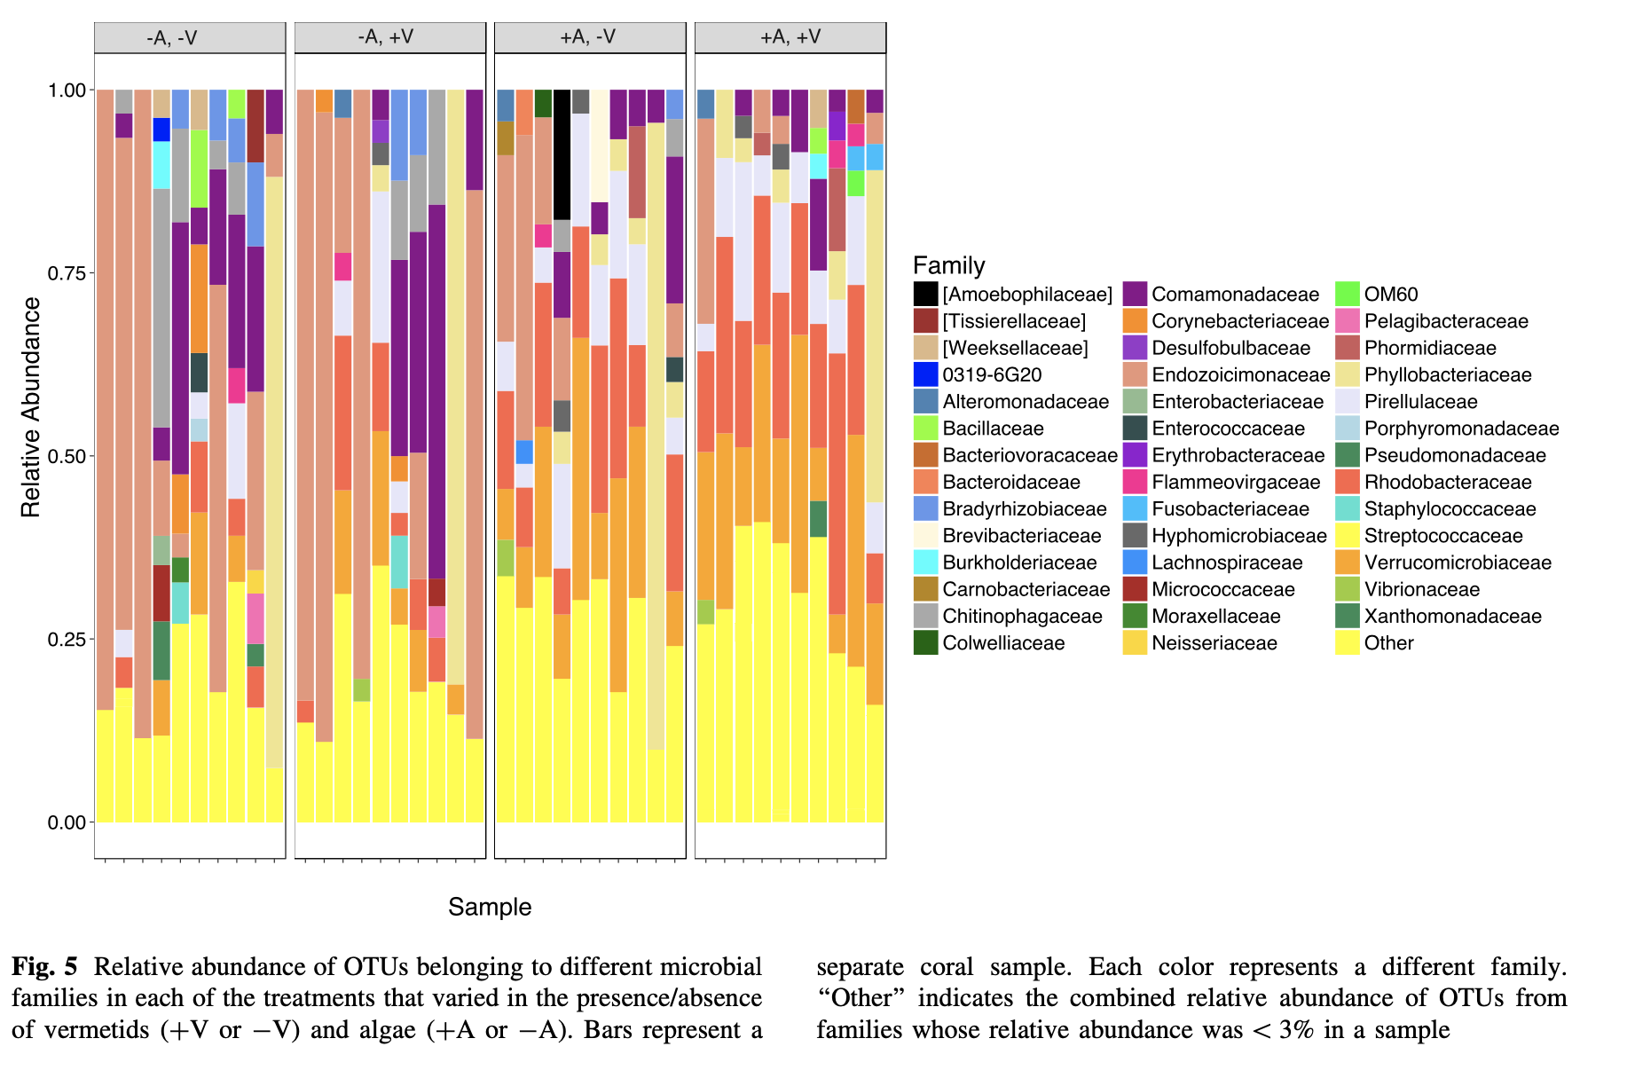

**Fig.2.5. The distinct microbial communities, shown using proportional color plots by individuals and by treatment, exhibit some variation among coral colonies when either algal turf or vermetid gastropods are present. From Anya Brown et al (2019) *Coral Reefs*. This case exhibits only slight variation among environmental treatment, which is why we will consider quantitative approaches to distinguishing samples or treatments in the next chapter and further in this text.**

The questions we may then ask include: how many distinct species in a sample? Is it higher diversity in one treatment or location than the other? Are the relative abundances of species the same in each of my samples, or do they vary in interpretable ways? (Mind you, if you aren’t a microbiologist you may have a hard time knowing *why* different OTUs (operational taxonomic units, the sort-of-equivalence to species in bacteria and Archaea) These questions require numeric or quantifiable measurements and will be addressed in the next unit.

**Example 3. Further partitioning diversity, beyond taxonomy.**

Where we eventually will become fluent in this class is in recognizing that our taxonomy - no matter what group of life you study - often does not reflect the true diversity of life very completely. It is extremely common to find that there are genomic distinctions among different spatial samples of the same species, and that these distinct populations represent variation in physiology, function, or other types of ecological interaction. As we begin to consider how organismal diversity responds to a warming planet, it has been tempting to think that *species* are gradually shifting to more poleward latitudes, for example. However, in many cases it is far more accurate to recognize how distinct *populations* vary in environmental tolerance and their ability to either move, adapt, or acclimate (Kelly et al. 2012).

The sequence data shown earlier from the barnacle *C. fragilis* are a good example of this. The overall divergence of sequences *within* this species are somewhat larger than typical for a metazoan, though still very distinct from the sister species *C. proteus*. However, if we collect enough DNA sequence data - in this case a common mitochondrial barcode region used in many metazoan studies, the Folmer COI fragment noted in Box 1 - we may see that the genetic distances among those DNA sequences easily group the individuals into 3 evolutionarily distinct lineages (Figure 2.5; Govindarajan et al 2015). In many ways this is only different in the sampling strategy from the microbial work mentioned earlier; we are asking “what is where” through sequencing (in this case, Sanger - individuals sequenced for a single gene are still done most effectively this way), and the sequences may identify new groups that are ecologically relevant or indicate intrinsic diversity in ecophysiology that are not reflected by the name of the species. Microbes on a coral, fungi in the forest, barnacles along a coastline - we know where they are in a general sense, but the specifics can tell us about functional and taxonomic diversity at a finer resolution.

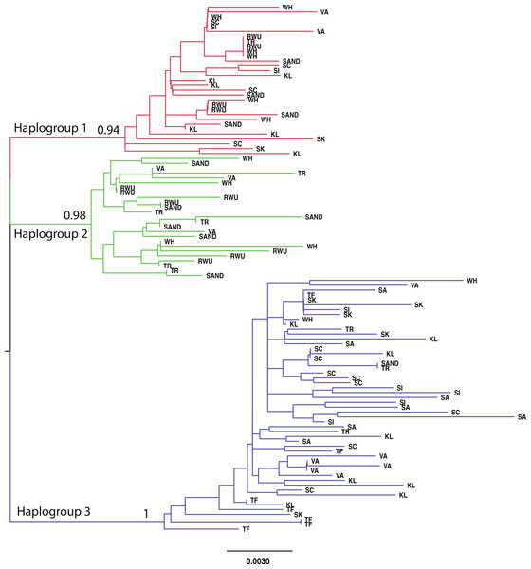

**Fig.2.5a. A gene tree representation of the sequence similarity among mitochondrial sequences sampled from the barnacle Chthamalus fragilis on the east coast of North America.**

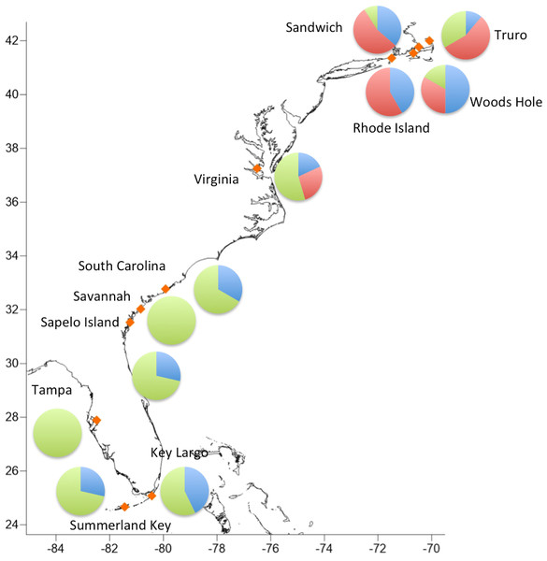

**Fig.2.5b. Spatial distribution of distinct phylogenetic clades shown in Fig.2.5a.**

This gene tree pattern (reflecting overall similarity of sequence, though the models for inferring these relationships can be mathematically complex in trying to estimate actual mutational difference among sequences) raises many questions, many of which will be addressed further as we gain skills in exploring the variation among sequences under expectations of single, randomly-mating populations in later chapters. However, by plotting WHERE each sequence was found you can start to assess that the diversity is not randomly distributed - the ‘red’ type of diversity is only found in the northern part of the range (Fig 2.5b). This appears to be an example where some diversity is more likely to be found in certain parts of the distributional (environmental) range of this species - suggesting variation in environmental tolerances or performance. To quantify this variation requires additional approaches, and to explore this hypothesis of local adaptation will require additional experiments.

By the way, if you were really paying attention as we plotted the barcode distances within *Chthamalus* above, you may have noted there was already a barcode gap - it just corresponds to a finer scale than recognized “species”! In the next unit, we will start to explore how ecologists and geneticists have somewhat independently identified similar approaches to measuring and distinguishing the diversity from distinct spatial or environmental samples, and will note where specialized metrics are necessary.

*For your exercise this week*, we will (a) learn how to use the free software Geneious at a basic level; (b) download DNA sequence data for a group of organisms of your choosing (roughly 8-10 sequences per species for 4-5 related species is a good size); (c) align the sequence data (we will do this in class); (d) use the resultant distance matrix data to plot your own “barcode gap” histogram (*with more guidance on how to use the R code above*) and ask how well this model of interindividual and interspecific divergence applies to the *taxonomic* diversity of your chosen group of organisms - what are the reasons it might not, and how could this understanding be applied to a question of distribution, abundance, or interactions?

*We will also take some class time to discuss the ‘reverse ecology’ approach mentioned in the Marmeisse paper, the overall consideration of how molecular ecology fits into natural history as discussed in the Travis 2020 essay, and discuss what spatial variation in genomic diversity means for the function, eco-physiology, and other types of variation in a species that may respond to a change in the environment. Finally we will also discuss the paper listed in Box X.*

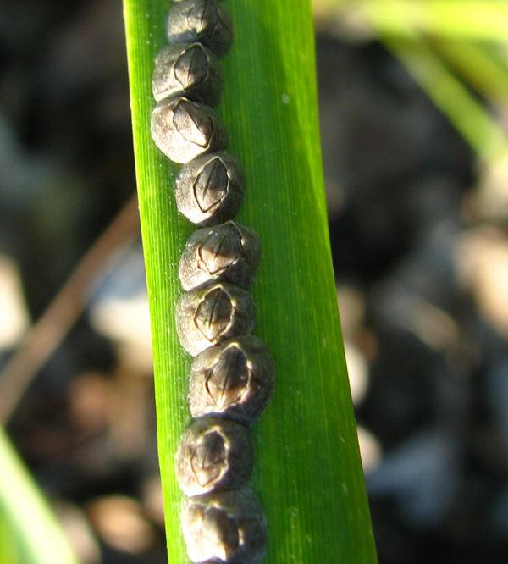

**Fig.2.6 - A row of *C. fragilis* settled on a stem of the cordgrass *Spartina alterniflora*. Photo by Y. Zhang, GCE-LTER.**

*Resources cited in this section* Brown, A. et al (2019).

Hamady M, Walker JJ, Harris JK, Gold NJ, Knight R (2008) Error-correcting barcoded primers for pyrosequencing hundreds of samples in multiplex. Nature Methods 5: 235–237. 10.1038/nmeth.1184

Katz et al (2009)

## Box B. An aside to explain these data better and how we obtain them.

This would be organized by electrophoresis (mobility, size and charge and cost) versus sequencing (method, informatics, cost). It will be brief and use online OA resources to clarify. We will note that later it will make sense that the information we can glean from sequencing, even models of thinking about rate and type of mutation, are useful even for electrophoretic markers and vice-versa.

In order to make any inference such as typical in molecular ecology, you have to have information. You have to have *variable* information, in fact. So, the history of this field is in finding ways to recognize that there is so much diversity in every single sample of life, and do it efficiently with available technology. As my colleague Jim Hamrick puts it, it is “high-tech natural history” so we often don’t have a lot of funding but we still have big questions!

The trick has been two-fold in our field. At first, we were technology-limited; it was difficult to obtain information on variable markers until the advent of protein electrophoresis in the 1960s, but those offer only a limited view into mutational diversity (and *may* be frequent targets of selection, see Skibinski & Ward 2004, Marden XXXX). Our second problem has often been just as significant, which is that improvements in technology are often expensive and lets face it: we are asking questions that don’t merit multi-million dollar NIH grants, in general (though the same methods of course have been appropriate for asking questions about **COVID-19**, see Trevor Bedford and others).

What this means is that the questions you want to ask are often influenced by how creatively you can use the available funding to do so. Though in 2020 it is becoming more common to see studies that involve whole-genome resequencing data - thus, there is a complete view of the genome, though some may want additional samples, or would still wish for methylation data, and so on - this is only possible when a well-scaffolded, complete genome is available. For many of us, that is simply not true and will not be true for quite some time (or until you get the $15-20,000 necessary to buy the data to do it yourself, but this can easily take a couple of years; Ruiz-Ramos et al 2020).

To save money, there are methods that focus on *anonymous* regions of the genome, those that focus on *targeted* regions of the genome, and there are distinctions in how the *targeted* data are obtained that tend to vary categorically with the number of regions being evaluated. The “anonymous” methods include what is currently known as genotype-by-sequencing (GBS, and the many flavors of “RAD” protocols that are collected to do this) and other methods that involve shearing the genome into fragments using microbe-derived restriction enzymes that recognize certain “words” in the genome and cleave the DNA in predictable ways. The extremely common enzyme *Eco*RI comes from the bacterium *Eschericia coli* and whenever it encounters a region in double-stranded DNA that has a **GAATTC** motif, it cuts the DNA in a way that leaves the **AATT* as a single-stranded overhanging bit of DNA, for example. What is nice is not only that the genome has been cut, but an easy way to bind adapter sequences is left behind for PCR-based methods.

The *targeted* data rely on prior knowledge about a gene region and its utility for your purposes. For example, probably the most frequently analyzed single gene region in metazoans is the mitochondrial cytochrome oxidase I gene region, for the simple fact that Folmer et al. (1994) published primers that tend to be able to isolate and amplify that gene region reliably in metazoans. We have subsequently figured out ways in which this gene region is particularly useful for molecular ecology, as well as particular drawbacks it has (Wares 2010) in terms of reliably transmitting information about mutational events. As scientists have wanted larger numbers of targeted fragments, the costs of PCR and sequencing either scale up linearly with the number of targets when doing traditional PCR and Sanger sequencing (roughly $1-4 in cost per ~1kb sequence per individual), or larger outlay of cash for enrichment protocols that allow next-generation sequencing to provide sufficient sequencing coverage of all the targeted regions. The cost of the sequencing is one part of the equation (e.g. in 2020 approximately 110,000,000,000 nucleotides can be returned from an Illumina sequencer for a cost of less than 1500 dollars), but how cleverly the underlying experiment is designed strongly affects the cost-efficiency of this approach.

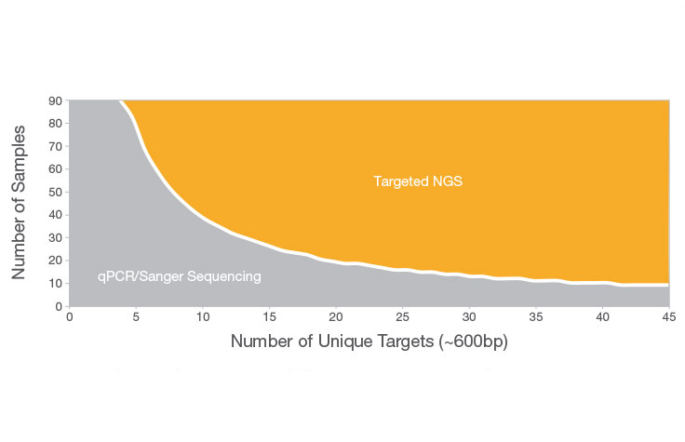

**Fig.B1 - From** [**https://www.illumina.com/science/technology/next-generation-sequencing/ngs-vs-sanger-sequencing.html**](https://www.illumina.com/science/technology/next-generation-sequencing/ngs-vs-sanger-sequencing.html)**, a rough guideline to the benefit of massively parallel “non-Sanger” seqeuncing as the number of focal loci increases.**

One type of *targeted* loci that can be analyzed efficiently with electrophoresis, separating fragments by their *size* rather than their actual sequence, include microsatellite markers or “simple sequence repeats” (SSRs). These loci vary based on short DNA repeats (e.g. ATC**ATC**ATC**ATC**…or GT**GT**GT**GT**GT**GT**GT…) that are highly mutable, and thus these loci tend to harbor higher diversity than other types of markers but also come along with distinct challenges, both practical and analytical. The fact that they only require electrophoresis to genotype an individual would seem to save money, but the effort to score these loci *and* the overall cost of multiple PCR reactions and submissions to a genomics center to be run on a capillary electrophoresis sequencer (often at a cost approaching $1 per sample, once costs of cleanup and electrophoresis are included) makes this of marginal benefit (K. Bobier, pers. comm.), and the cost to develop these relatively taxon-specific markers (doing enough sequencing to find the repeat regions whether via enrichment or filtering, primer design and basic testing - often on the order of thousands of dollars for a new series) has probably put them into the historical dustbin except for cases where they already work on your organism.

So, suffice to say there are *so* many ways to collect data representing genomic variation and you have a few variables to work with. *How much money is available for this work? How many individuals should be genotyped, at how many loci, to satisfy your question?* At this point in the book, you maybe don’t know. *How many individuals do you genotype to figure out whether broods of barnacle larvae (or seed pods of tropical trees) are fathered by a single individual, or multiple? How many locations do you need to assay to understand your overall system - and how many individuals from each location?* (not to mention the cost and effort of *finding* those individuals, often a considerable effort itself)

This is the challenge in teaching about the markers. They change constantly via technology and the availability of resources; the questions and the statistics used to answer those questions change far less over time, thus we are going to move forward moving with the simplest types of data (and simplest types of analysis) first. The exceptions necessary for dealing with certain types of data - are the data haploid? Or uniparentally inherited? Are the data dominant or codominant? In other words, you will also need to understand the **natural history** of the markers you are studying, as noted by famed paleontologist Geerat Vermeij (2003).

A few other notes as we talk about the ‘natural history’ of our markers. It has been common to talk about loci that are neutral versus those that are not. Usually, in the context of declaring the data to be neutral because they are mitochondrial (Avise) or microsatellites, or simply because they have no known relationship to functional or quantitative diversity. What we are really saying is that the data have very little known about this relationship, but that the assumption of neutrality is often a very very big assumption (Hahn 2008; Rand, Wares 2010, and so on). The extent to which this type of work is “genetics” means that you have to know how it is inherited (only from maternal? Or is it a freshwater mussel, and the mitochondrion will reflect paternal diversity *when in males*), and you have to know how your technique for capturing it will reflect that diversity - is there potential for null alleles that do not amplify because of variation in primer sites? Will you only capture the presence of an allele, and can not distinguish between homozygotes and heterozygotes? Would you expect the relative abundance of particular genomic sequences to reliably indicate the relative abundance of the organisms they come from in an environmental sample? Why or why not?

So we are going to treat the natural history of loci, and the methods to obtain the data, as opportunities to consider exceptions to the rule rather than a basis to build upon. The best data means that you have sequence data, and a lot of it - and you know what to do with it. Here we go!

# 3 A bit more biological reality, and how diversity is generated

One last key set of details is going to be important for us knowing how to ask the right questions using molecular data. So far we have talked about using molecular assays to find genomic variation in individuals and samples of individuals. We haven’t really talked about where that variation comes from, and the reason that is important is that almost all of our questions rely on this variation telling us something about *rates of change per unit time*.

## 3.1 How diversity is generated by mutation

Mutations are errrors. Simple as that. When we teach introductory biology, there is a single equation for how photosynthesis converts light and water into glucose and oxygen; but there are any number of ways in which that metabolic pathway sometimes misses a step or hiccups, and that becomes more frequent as the environment changes away from the conditions that a photosynthetic organism is adapted for. So, we recognize that as ocean temperatures increase, photosynthetic dinoflagellates living in corals are more likely to produce tissue-damaging oxygen radicals, and they are ejected by the coral hosts - causing bleaching. <https://www.youtube.com/watch?v=_ZfGIKiSwwQ>

Similarly, mutations happen when DNA replication has an error, as with ‘strand slippage’ changing the number of repeats in a microsatellite or adding a G instead of a C as nucleotides are incorporated; or when ultraviolet light or a chemical toxin damages the DNA and cellular repair mechanisms don’t catch the change.

We should recognize that mutations are happening all the time, though not always with evolutionary significance. Many cancers are caused by *somatic* mutations that only affect the diversity in the cell(s) descended from the initial mutation, for example. However, when mutations appear in a cell or tissue that has the capacity to reproduce and make new organisms (“germ line”), those new organisms will carry the mutation that occurred in the previous generation.

How do we know that mutations happen all the time? First of all, a rather famous experiment by Luria and Delbrück showed that bacteria grown from a single cell in a culture medium until there are many millions of cells have a non-zero probability of a mutation affecting their tolerance to antibiotics. If the mutations only appeared *because* of the change in the environment, we would expect a fairly constant rate of response across replicate experiments; the high variance in outcomes mathematically showed that mutations were sometimes happening early in the growth of the culture (so more cells are resistant when plated on antibiotic medium), sometimes late (very few cells are resistant), or not at all. That tells us that mutations are independent from any *response* to the environment; some environments may promote mutagenicity, but the mutations that arise are not specific to that environment.

Intriguingly, we can also track mutations happening in long-lived and clonal organisms. A great example would be aspen trees (*Populus tremula*), which grow in massive clones with shared root systems. Distinct clones may be noted during autumn, as leaves turn from green to brilliant gold, because large patches of trees will all turn at the same time - but not synchronously with patches next to them. Sequencing portions of the genome from one edge of a clonal individual and then from a tree at the opposite edge assumes that the clone is expanding outwards from its original propagule (seed), and thus many years have passed since those two sequences came from the same cell. It is typical to find that these trees on opposite sides of the colony are genomically distinct (though still clones), and because each tree has its own reproductive tissues the gametes they produce will carry those distinct mutations. Similar approaches have been used to look at mutational diversity in other tree species (<https://doi.org/10.1098/rspb.2019.2364> for *Eucalyptus*, Fig 3.1), and have even been able to use the growth form of trees to identify the actual rate per amount of tissue growth or per generation!

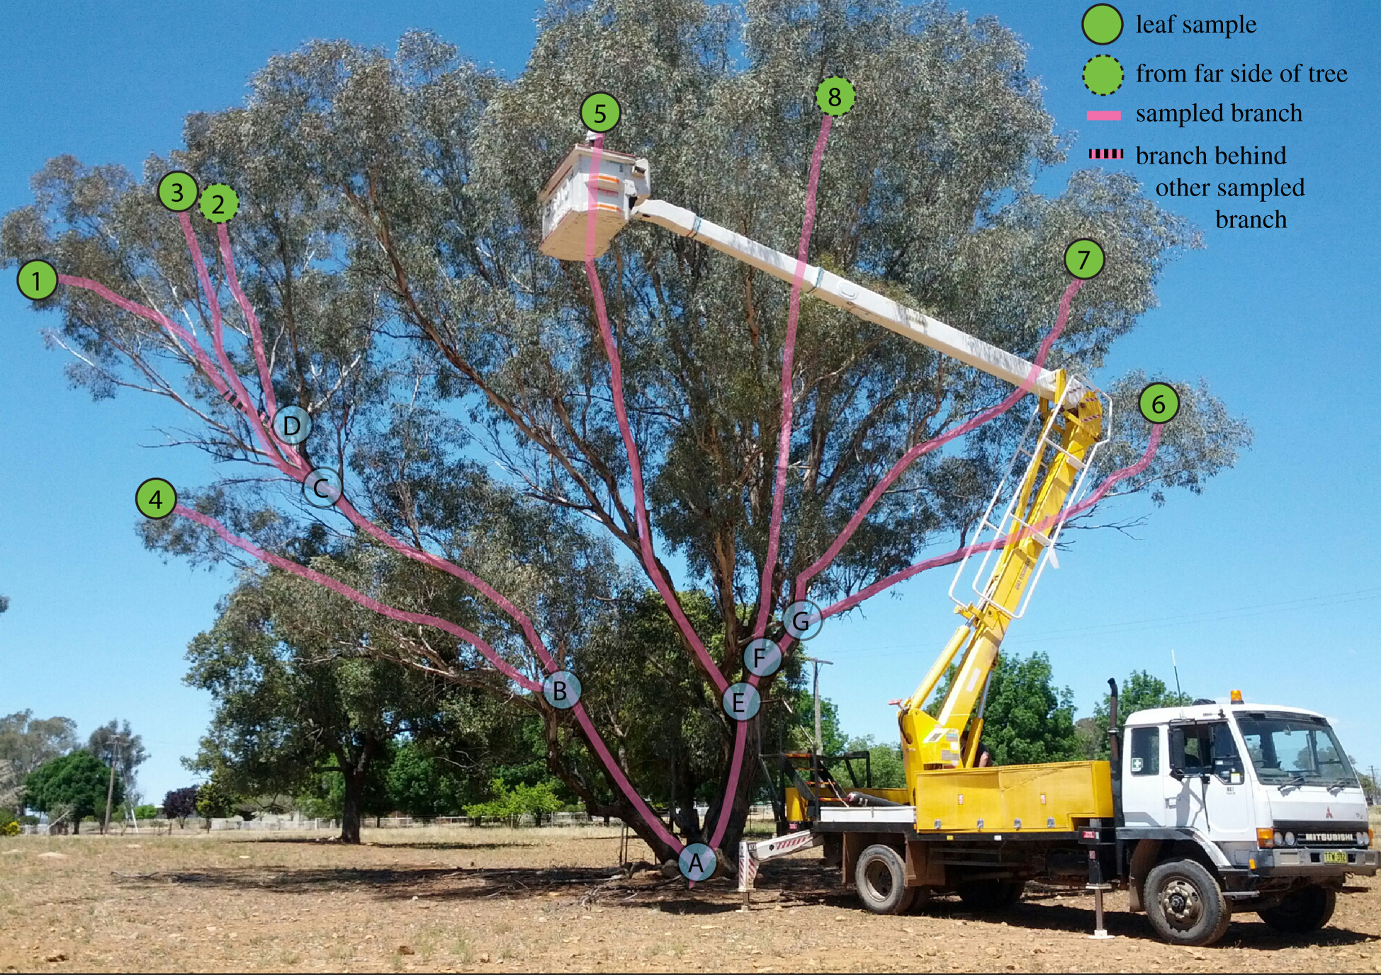 **Fig.3.1 - From** [**https://royalsocietypublishing.org/doi/10.1098/rspb.2019.2364**](https://royalsocietypublishing.org/doi/10.1098/rspb.2019.2364)**, showing how the ‘phylogenetic’ growth of *Eucalyptus* can be taken advantage of for studying somatic mutation rates in these trees and comparing with simpler ‘model’ organisms like *Arabidopsis*.**

A fascinating recent paper by Olsen, Levitan, and others (<https://www.ncbi.nlm.nih.gov/pubmed/30707605> ) looked at this same question in corals in the Caribbean. Corals tend to start their life as either a tiny planula larva, created by the formation of a zygote from spawned eggs and sperm, or as a small chunk of coral that has broken off from a nearby colony. As the colony grows from this point, again mutations may happen in individual polyps (each polyp eats, photosynthesizes, and can reproduce, but all share a common gastrovascular connection), and mutational diversity can be found between polyps on either side of the colony. What was really cool about this work (Olsen et al 2018, *Biological Bulletin*) was that they evaluated many coral colonies from 2 species, at different depths and different sizes. The two species have different growth forms and rates, so the genetic distance between polyps from the same colony depended on both size and species identity; even more interesting, the mutation rate was higher for shallow-water colonies, suggesting increased exposure to ultraviolet radiation from the sun.

*The data in the Olsen et al paper came from microsatellite loci. As noted in Box B (Chapter 2), this is a method that depends on isolating and identifying regions in the genome with simple short repeat (SSR) sequences and then targeting them using PCR. The products are scored by their relative migration under electrophoresis, using a size standard that fluoresces a distinct color from the PCR amplicons so that the products can be scored to size. Though a particular allele may have 14 repeats of “AGT” (14 x 3 = 42), the PCR amplicon will include flanking regions that extend the fragment length so that there is a space for primers to match for PCR; thus that same allele may actually be a PCR amplicon that is (for example) 120 base pairs in length. The fragment length is generally what is scored, and in the best cases each allele is scored at length intervals that match the repeat element length (so for the example locus, we might see other alleles at 117, 123, 126 and so on). Later in this chapter we will see more about how mutational differences are counted among these fragments, but they offer a highly variable (good) but imperfect view of genome diversity that requires special consideration.*

These examples from bacteria, trees, and corals are natural examples of “mutation accumulation” (MA) studies, which can easily be done (with time!) in lab organisms with short generation times, such as *Arabidopsis*, yeasts, and so on. Often of course in order to do such work you not only need a short-generation organism that is amenable to culturing in the lab, but also the resources to sequence large amounts of the genome since the *location* of the mutations will also be, for the most part, random. To understand how mutation happens in the rest of diversity, biologists have looked at well-known geographic features that separated ancestral populations into two or more descendant populations, and can ask similar questions about how many mutations distinguish those populations.

Estimating the mutation rate, $μ$, from these long-term isolated populations requires that we make one additional assumption. Since we are only looking at the end-point of many hundreds or thousands of generations of isolation, many mutations will have arisen - and some will disappear quickly, some will stay in the population as segregating diversity, and some will go to ‘fixation’ (the novel mutation is now present in all members of the population). If we assume that the mutation has absolutely no good or bad qualities with respect to the survival or reproduction of individuals (“fitness”), then whether it increases in frequency each generation or decreases is pure stochastic luck. It depends on the fact that populations are finite in size, and that for unpredictable reasons not all individuals will have the same number of offspring - some zero, some one, some many. Because of this simple fact of variation in reproduction, the frequency of a mutation changes randomly each generation as shown in this simulation of **genetic drift**:

library(learnPopGen)  
driftplot<-drift.selection(p0=0.2,Ne=500,w=c(1,1,1),ngen=2000,nrep=10)  
#this is terrible slow code  
library(ggplot2)  
  
#shinyAppFile("/shiny_popgen-master/Drift/drift_app.R",options=list(width="100%",height=600))  
# how do I get it to start off with frequency 0.2, certain generations and so on?  
#run it and download the .csv, read back in and plot it!  
  
#pop500<-read.csv("drift-simA.csv",header=T)  
#ggplot(data = pop500, aes(x=generation, y=freq)) + geom_line(aes(colour=sim))

The plot shown is based on simulating drift, as we have done before in this class. In this case, the starting frequency was low (0.2) – but not as low as a new mutation – and the population size *N* is 500. So that we refresh in our minds how this works, there is also a Shiny app that lets you control these parameters (nb unless otherwise noted, the Shiny popgen apps are by Silas Tittes <https://github.com/silastittes/shiny_popgen>).

**FOR OUR JUNE 1 MEETING WE WILL NOT YET HAVE ACCESS TO THIS EXERCISE**

library(ggplot2)  
  
#shinyAppFile("shiny_popgen-master/Drift/drift_app.R",options=list(width="100%",height=700))

Your task with this simulator is to learn about a key understanding about random genetic drift. Remember, at this point in time all diversity we have talked about has no known effect on **fitness**. You can see from the app above that you can change population size (*N*), the initial allele frequency, how long (generations) to run the simulation; *as well as “bottleneck time” and “bottleneck pop. size”. Don’t worry about these last two, but be sure to set “bottleneck time” to be greater or equal to “generations”.

Now, varying *N*, starting allele frequency, generations, and number of replicates - I’d like for you to set up some simple observational experiments to *quantify* the probability that the allele we are tracking (it is at the frequency you set; the other allele is, of course, at (1-*freq*) in frequency) goes to fixation (frequency 100%). I suggest starting with small population sizes, but then see if it changes as *N* increases.

Second, now that you have run that experiment and described your approach and results (you will email this to Dr. Wares), identify the conditions (including how many loci or observations or replicates are necessary) that allow an allele starting at frequency 0.01 to go to fixation. If you increase *N* to 1000, does the likelihood of fixation change? Or does the time required for fixation change?

Again, email these results to Dr. Wares *before you read ahead*! If you are stumped, its OK to email a classmate or email me 😄

OK, now close your eyes, imagine a simulation starting at a frequency *f* for 2 alleles (that is, one allele at frequency *f*, the other at frequency (1-*f*)). This is an ancestral population. If that population is, by whatever environmental mechanism, separated into two distinct populations, how often do you think the two locations being sampled will have a different allele present in 100% of individuals?

As you can now recognize, given enough time relative to *N*, there will be plenty of instances in which a polymorphism goes to fixation in one location/replicate, and, relative to the “other” location/replicate would be a **substitution**.This small simulation is not truly realistic in terms of the starting frequency of a new mutation of course. If there are *N* individuals in a population, then a brand new mutation would appear at a frequency of 1/*N* (or really 1/2*N* for a diploid locus); but there would also be many more such opportunities across a whole genome, across many generations. Kimura’s “neutral theory” predicts that the probability of a mutation going to fixation is equal to its frequency when observed, so with the simulation above in the figure - given enough time - we would expect 20% of the simulations to go to fixation and become a substitution. With a new mutation, that would be a much lower probability of 1/*N*. However, in each generation you have an opportunity for mutations to happen on all chromosomes in the population, in other words *N* times the mutation rate $μ$. Long story short: **if the mutations are neither advantageous nor disadvantageous** (neutral, not selected for or against), *the rate of substitutions is equal to the rate of mutations*.

This means that if we go back to our genetic distances from Chapter 2 - the mean number of mutational differences between sequences from populations that have been separated for a long period of time (*t*) can tell us what $μ$ is if we have a good idea of what *t* is. This, too, is the simplest model for how we approach this problem and later in the semester we can identify ways to increase the accuracy of this inference.

## 3.1.1 Examples where we think we know *t* for this purpose

Abundant geologic evidence and radiometric dating have shown that volcanic activity formed the narrow land bridge between South America and Central America where now Panama and parts of other nations are found. Prior to this happening, there was relatively free exchange of marine organisms between the Pacific Ocean and the Caribbean Sea. The geologic dating estimates that the land bridge had closed off this passageway around 3.5 million years ago (mya), sundering those marine populations into demographically distinct Pacific and Caribbean populations. At this point in time, each population was likely genomically indistinguishable from the other; but in 3.5 million years, many new mutations have arisen and gone to fixation in each population, and we assume those mutations and probabilities to be completely independent from one another.

Mutation is treated as a Poisson-distributed random process, meaning that we treat mutations as independent events in a genome, that the rate is very low but constant for a given time step, and we assume that the rate is low per time step so that only one event happens at a time. <https://towardsdatascience.com/the-poisson-distribution-and-poisson-process-explained-4e2cb17d459> This probabilistic assumption can be used to consider how many lightbulbs must be purchased to keep all lights functional on a University campus - and the likely number needed to be replaced in any particular building or room. Importantly, even though the events are stochastic our estimates of the rate $μ$ still relate the number of events to time.

So, we can look at these separate populations and calculate their overall divergence $d_{xy}$ based on the proportional difference of sequences from the two populations, as in Chapter 2 - and because the mutation rate $μ$ has applied in **BOTH** populations over the same stretch of time *t*, that genetic distance is equal to 2 $μ$*t*, or $μ$ = $d_{xy}$/2*t*. In this case, a famous early study by Nancy Knowlton looked at populations of snapping shrimp in either basin, assuming *t*=3,500,000 and they estimated $μ$ for typical mitochondrial protein coding loci to be around 2-3% divergence per million years. This is called “calibrating the molecular clock” and of course is still a very simplistic way of thinking about how mutations will arise and be retained in very different parts of the genome, under different evolutionary mechanisms, but it is a common starting point for these analyses - and tends to fit well when other organisms are evaluated, as long as the same gene region is evaluated.

Similar approaches have been taken in instances where we have good geologic data for the temporary submergence of a land bridge such as the northern portion of Baja California, allowing new movement across that land bridge; when erosion allows the headwaters of one river to “capture” the diversity of another river, effectively moving the fauna and flora of the second river into the first and isolating the two populations afterwards (“river piracy”, J. Waters and others); or when knowledge of climatic change through time allows us to know when populations of mice that are now only found on the tops of mountains in the Rockies used to be connected through gene flow in the valleys during cooler climates.

## 3.1.1 How we infer the number of mutations, thinking of whole genomes

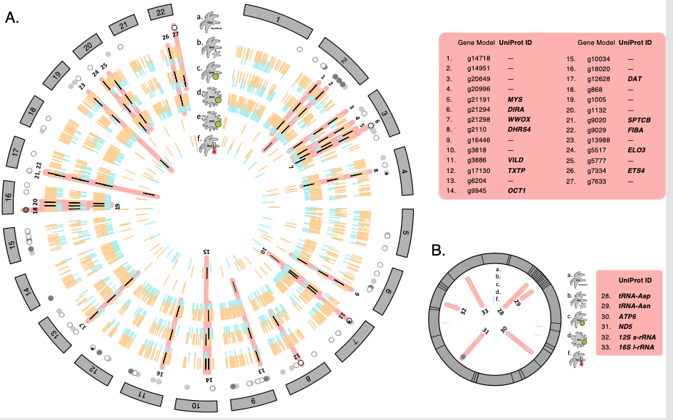 **Fig.3-2. A ‘circos’ plot of the 22 chromosomes of the *Pisaster* genome, a number validated by old chromosome squash data. More internal circles include aligned data of single-nucleotide polymorphisms from Schiebelhut et al 2018, and differential RNA expression data from several other studies as summarized in Ruiz-Ramos et al. 2020.**

A genome is tremendously complex. Figure 4-1 illustrates the complete genome of the sea star *Pisaster ochraceus*; there are 22 chromosomes (chromosome pairs in a diploid individual), comprising about 400 million DNA nucleotides. Although it is now possible to ‘re-sequence’ the genome to find polymorphic sites, the complications of looking for potential gene rearrangements or inversions; dealign with recombination among sites; and the cost of doing so can be prohibitive and beyond the needs of a study. A lot of the data used in the field of molecular ecology are used because they allow a more efficient or inexpensive analysis that is sufficient for the purposes of the question. For example, the circles plotted in the first ring inside the chromosomes represent 100 SNPS (single nucleotide polymorphisms) that exhibited strong frequency shifts after sea star wasting disease killed ~90% of all individuals of this species (Schiebelhut et al 2018 PNAS). The pink radiating bars represent overlap between these markers and RNA-based expression data that suggest similar responses across data sets, even across other species influenced by wasting disease (Ruiz-Ramos et al 2020 Molecular Ecology, where this figure comes from). How much data, what kind of data, and what sampling strategy is needed to answer your questions?

Essentially the history of population genetics and molecular ecology follows the history of technical advances allowing us to see genomic diversity with greater breadth and resolution. Each technical advance allows greater consideration of the detail of these data, and so various models are used essentially to link the identity of any two sequences (using the term now sensu Hahn 2019 to disambiguate from the two alleles that each individual carries at a locus, whether identical or not) with the time since they shared a common ancestor. As with Hardy-Weinberg equilibrium and the ‘match’ of different ways of evaluating diversity, when these distinct models generate different estimates of diversity, we can assume that some evolutionary mechanism is involved, as we will soon see through examples.

In an ideal world, we know how many mutational events distinguish two sequences. In this way, we can recognize that mutations may even happen at the same location in a genome if enough time passes, and so people studying molecular evolution or phylogenetics of a group of distantly related organisms will make assumptions about the frequencies of transitions (a pyrimidine changing to another pyrimidine, or purine to purine, as with C->T or A->G mutations), the frequency of nucleotides in the data, constraints on the molecule such as codon models, and more in what are called **finite-sites models**. Having a tremendous amount of data and complex substitution models does not guarantee a lack of rancorous debate over the outcome of such analyses, of course, as with recent discussion of whether ctenophores (<https://en.wikipedia.org/wiki/Ctenophora>) are the most basal metazoan or not. Those methods are kind of out of the scope of this class and are often called “molecular evolution” or “phylogenetics/phylogenomics” or “molecular systematics”, depending on the goal of the analysis.

On more recent time scales however, we can make some simplifying assumptions that work for most of the types of questions we are interested in as ecologists. A widely-used model is the **infinite-sites model**, which assumes that every mutational event occurs at a new location (site, nucleotide) in the genome and thus the number of distinctions between any pair of sequences is an indication of the number of mutations, and that leads us back to inferences of time. This model applies to cases where we are directly observing at least a portion of the actual nucleotide data, whether via traditional Sanger sequencing (a separate reaction for each sequence, individual specimens are handled distinctly, a total cost of perhaps $0.005 per nucleotide per individual per sequence) or high-throughput massively parallel sequencing with bioinformatic approaches to sort out the data after sequencing, where many individuals and loci are obtained at once - with a much higher *minimum* cost to a project, but orders of magnitude improvement on the cost per nucleotide/individual/locus.

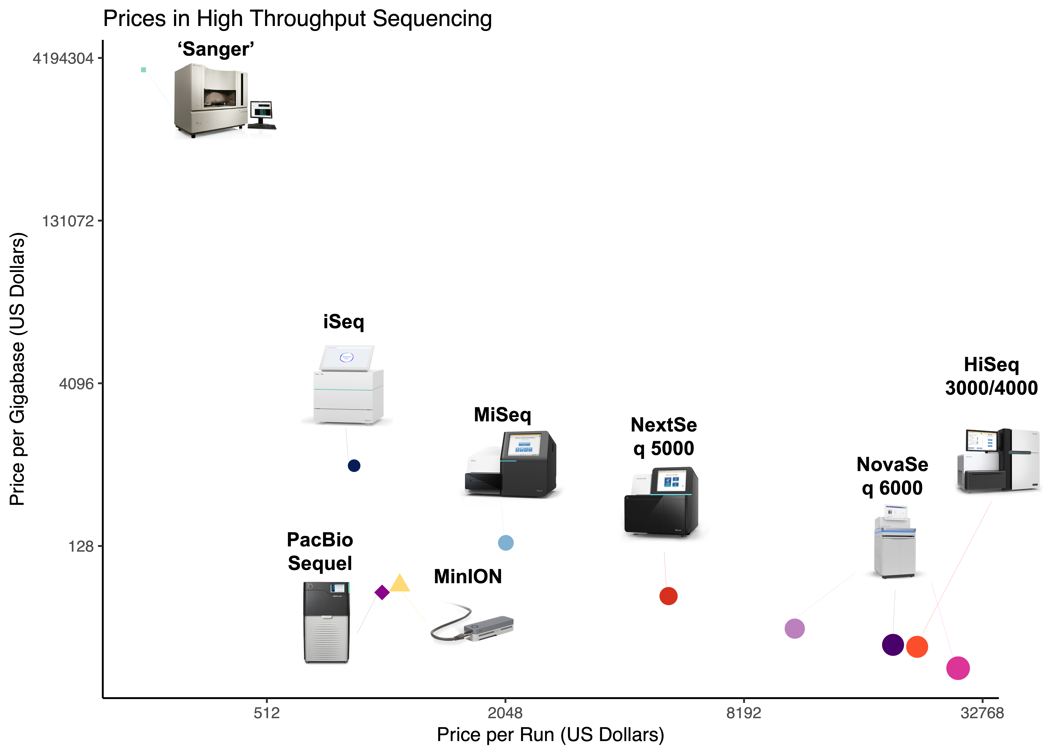 **Fig.3-3. Cost per base pair on different DNA sequencing platforms; figure by N. Bayona-Vasquez, 2018 - things changing SO fast though, can now (2020) get 110gigabases of data for <$1500 (e.g. HiSeqX at novogene.com 😄) but Sanger sequencing costs have not improved 😦**

However, until only about 10 years ago, to study multiple loci via actual DNA sequencing (per locus, per individual) was increasingly prohibitive in time and money because of the cost of Sanger sequencing and the effort to get reliable PCR amplicons for highly variable genome regions (Fig 3-3, see **Box 1**, e.g. Wares et al 2009 put a great deal of effort into having data from 5 loci across roughly 50 individual chthamalid barnacles). So, an alternative for finding highly polymorphic loci might be simple-seqeunce repeat (SSR) or “microsatellite” markers, where mutations caused by *in vivo* polymerase error lead to heritable fragment length polymorphisms that are codominant - both alleles can be known for a locus from a single PCR and electrophoretic analysis - and could even be multiplexed for reasonable costs per locus per individual (many studies having 10-20 distinct loci for 10s or 100s of individual organisms). The drawback to microsatellite markers was often in their specificity to a particular species, so great effort went into developing them - and by not evaluating the actual DNA sequence (and length homoplasy being a common problem), mutational differences among alleles have to be estimated with something like a **stepwise mutation model** (SMM; where fragments of similar length are assumed to have a more recent common ancestor than with a fragment of very distinct length) or they are treated as having *unknown* relationships under an **infinite alleles model**.

The infinite alleles model (IAM) simply says “these fragments are different” but without knowing whether 1 or 2 or 10 mutational events happened since they descended from a common ancestral fragment of DNA. In other words you either have, or are using, far less information in this case (but it is also a simple model, and not likely to be misled by big deviations in your assumptions). This model works for protein electrophoretic variants (allozymes) and some types of dominant markers as well, and can be used to simplify assessment of sequence variation as well. For example, in Figure 2.2, 6 sequences are shown and there are 4 distinct alleles represented by that diversity. Without counting the number of nucleotide differences, we can still represent the number of distinct alleles under this model; each polymorphic site represents a mutation that has happened in the history of the sample.

So looking back in time, older data *required* simpler models wtih less resolution, but those simpler models can still be used to assess the diversity among a collection of DNA sequence data. As noted above, the mutational diversity in a sample depends on two things: the mutation rate, and the number of individuals reproducing. So, we talk about a population mutation rate $θ$ that is the product of these two. For example, one estimator of $θ$ operates under the IAM; Watterson’s $θ$, hereafter (W), is just a count of the number of polymorphic/segregating sites (K) divided by a factor that accounts for the sample size (larger samples will recover more diversity, typically).

1. = $\frac{K}{a_{n}}$

where $a_{n}$ is the sum of 1/*i* from *i*=1 to *n*-1 in a sample of *n* sequences. (W) is an estimator of the population mutation rate $θ$ and a value is obtained from the observed data. But in our barcode data (Fig 2.2), we already talked about another way to estimate diversity among sequences; the average pairwise proportional distance between all sequences in a sample, used at that time to characterize the distribution of how different sequences might be, is equivalent to another estimator of the population mutation rate called **nucleotide diversity**, or $π$.

**remember we are still talking about sequence or marker variation, and not accounting for how it is combined in diploid/polyploid individuals**

The fact we are currently reading about sequence data, or estimating mutations between markers that are *proxies* of sequence data (the length of a microsatellite fragment approximates the knowledge of the actual sequence, for example), means right now we are not actually talking about allele frequencies in the same way as in the drift simulation above. We’ll get to that - it turns out that there are reasons why diploid genomes are more complicated, even though you were all taught Hardy-Weinberg in high school probably!

The cool thing about (W) and $π$ is simply that they are two related but distinct ways to estimate how mutational diversity should be distributed in a population if we assume a single, **randomly mating** population with no **immigration** from other populations, no **selection** acting on the diversity, and the **mutations** happened before we sampled the diversity. You will see by Chapter 4 that these are pretty interesting constraints for when those two estimators should generate the same estimate of $θ$.

First, lets revisit what population size *N* does. Because not every single individual has the same number of offspring - think about the many acorns an oak tree drops, yet on average *all oak trees* only replace themselves at best; some will live a lifetime with no offspring that succeed, others will have many, the average is one in a stable population. The same could be said for the very few Devils Hole pupfish; they have a small population size that is absolutely constrained by the extent of their environment and food resources. If we start with an assumption of allele frequency - 2 alleles at equal frequency - how quickly does that allele frequency change?

#library(learnPopGen)  
#oh god I don't see the cache file this takes a LONG time because of first sim; get the cache working  
#oakdrift<-drift.selection(p0=0.5,Ne=5000,w=c(1,1,1),ngen=400,nrep=5) #for now not compiling  
#devildrift<-drift.selection(p0=0.5,Ne=100,w=c(1,1,1),ngen=400,nrep=5)  
  
#shinyAppFile("/shiny_popgen-master/Drift/drift_app.R",options=list(width="100%",height=600))  
# set this for specific params, read back in and plot for them  
  
popoak<-read.csv("drift-simOak.csv",header=T)  
#names(popoak)<-c('V1')  
ggplot(data = popoak, aes(x=generation, y=freq)) + geom_line(aes(group=sim,col=sim)) + ylim(0,1)   
  
#ggplot(data = popoak, aes(x=generation, y=freq)) + geom_path(aes(colour=sim) + scale_y_continuous(limits=c(0,1),breaks=seq(0,1,0.2)))  
  
#ggplot(data = popoak, aes(x=generation, y=freq)) + geom_path(aes(colour=sim) + ylim(c(0,1)))  
  
#popoak2<-read.csv("drift-simOak2.csv",header=T)  
#ggplot(data = popoak2, aes(x=generation, y=freq)) + geom_line(aes(colour=sim))  
  
popdev<-read.csv("drift-simDev.csv",header=T)  
ggplot(data = popdev, aes(x=generation, y=freq)) + geom_line(aes(group=sim,col=sim)) + ylim(0,1)

You’ll note a very different amount of change in the oak tree (top) versus the pupfish (bottom). The point is, the top one has a very large (effective) population size, the bottom one has a very small one. How we get to the (effective) part comes later. But do you see the clear distinction? In a large population, random change happens slowly and doesn’t lose diversity quickly; in a small population, change happens fast and diversity is lost. We will eventually be able to use this relationship to look at turnover in allele frequency between distinct temporal samples from a population and try to estimate what the (effective) population size actually is; the parentheses are there because this is hard for all sorts of reasons, but I hope you can already see it is of ecological interest. One thing you will come across later is that the because the rate of fixation is faster in small populations, we can see that the overall rate that heterozygosity is lost at a locus is ~1/*N* per generation, which is why small inbred populations are of management concern.

So, in finite populations, you will see changes in allele frequency from generation to generation, and likely it will not - on its own - create more change than you’d expect from your modest sampling effort of genotypes to be able to predict allele frequencies. Again, this will come into play as we try to work backwards from allele frequency shifts to (effective) population size.

Anyway, that is what happens as time moves forward from a set of *assumptions* (the allele frequency, the effective population size). Typically, what we want to do is take observed data and ask *how they came to be that way* - though predicting the future is ultimately our goal (Bay et al 2018), we have to first figure out what we can learn from our reconstruction of the past.

Kingman (1982) is a definitive starting point for understanding the equivalent model to drift, but moving back in time from the data we can currently observe. What are those data? In this case, we are assuming sequence data from a fragment that is large enough to have multiple sites of mutation (of different ages, thus leading to interesting patterns) and it is *at least mostly* not recombining within the history of the sample, which is why there are useful patterns in the data. We can deal, and will deal, with recombination as well. This is the problem with models, all of them are wrong because there are always more complexities in a natural system - but some are useful (quote).

This “coalescent” model works with a similar but more explicit assumption of how each generation is related to the previous. What is known as the **Wright-Fisher** model applies to discrete generations; things can be dealt with, but are somewhat more complex, with overlapping generations (Charlesworth; Turner et al 2002; Hahn 2019). It is pretty much drift in reverse: if effective population size is small, it doesnt’ take long for the diversity to *coalesce*, to be descended from a single common ancestral allele or lineage.

So, lets talk about the Wright-Fisher model. This means that you have a population size *N* and in the previous generation each of those *N* individuals were descended from *randomly* chosen ancestors of population size *N*. The “random” means that with probability 1/*N*, 2 individuals have a common ancestor for each generation back in time (and a probability 1-that, that any 2 do not). There are fewer good R simulations for this process but this one I like:

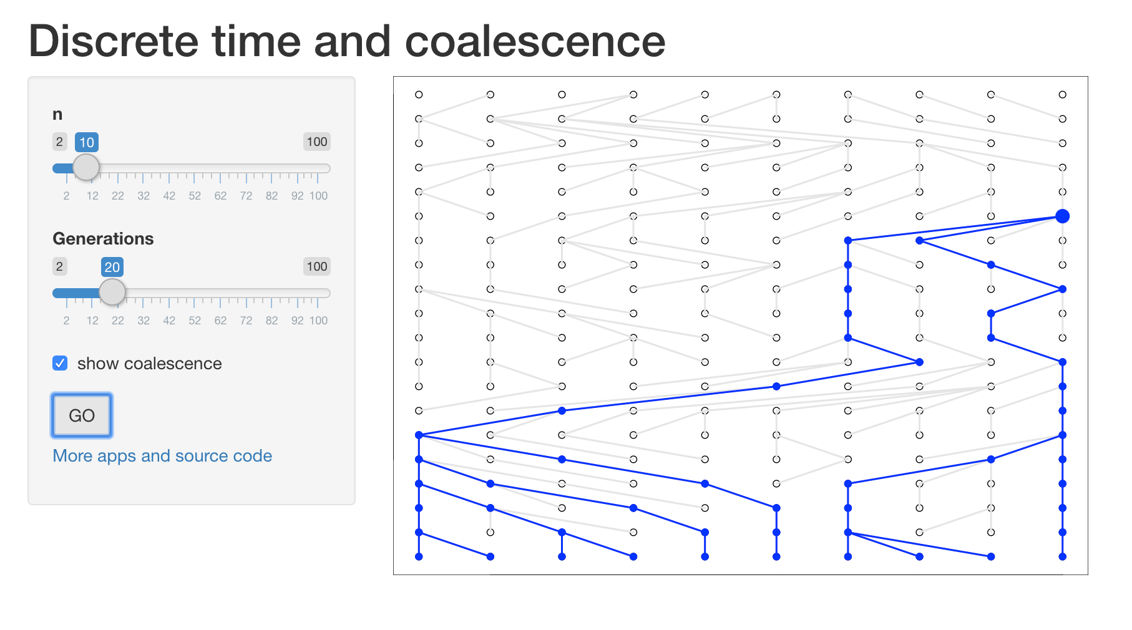 **Fig.3-x. Coalescent simulator; the SHiny app is below.**

#shinyAppFile("shiny_popgen-master/Coalescence/discrete_time_app.R",options=list(width="100%",height=600))

The top panel is a static image of the Shiny simulation built in below it. If you set n=10 and generations =20, you can run this simulation several times and will see very different outcomes. This is a dramatically oversimplified version of looking at how coalescent theory works, because in this case the sample size *n* is identical to the population size *N*, so there are many rapid coalescent events - but of course as you increase *n* to its maximum (in this visualization) of 100, you cannot see the events as clearly. It is true that in very small populations (for example the Florida panthers in the late 1980s) all individuals sampled will have very recent common ancestors (both the biological and casual use of term “inbreeding”). But the dynamics of coalescent theory have broad implications for studying genomic diversity in populations of any magnitude.

#install.packages("coalesceR", repos="http://R-Forge.R-project.org") did not work right, try again  
#library(coalesceR)  
#coalescent.plot(n=10,ngen=20)  
#get package names  
#pckgs <- c("tidyverse", "shiny", "wesanderson")  
  
#determine if packages are installed already  
#miss <- pckgs[!pckgs %in% installed.packages()]  
  
#install missing packages  
#if(length(miss)) install.packages(miss, dependencies = TRUE)  
# going to try shiny_popgen but not sure how to include in Rmd yet...  
  
#shinyAppFile("shiny_popgen-master/Coalescence/continuous_coalescence_app.R",options=list(width="100%",height=600))

The Shiny app for coalescent simulation in the above panel is more technically useful, because you can set the number of sequences sampled *n* as well as $θ$, which you will remember is the product of the population size *N* and $μ$ (and a scalar related to the number of gene copies). You see that because *N* is much larger than *n*, the *coalescence* of two sequences happens a much longer time in the past (and time itself is measured relative to $θ$, so it is not absolute in units of generations or years). Again, set up the parameters so that you can see that a large number of highly variable genealogies are consistent with this process, and mutations are randomly (Poisson distributed by time) placed on the tree. Together, these generate the patterns of mutational polynmorphism that we expect when we use (W) and $π$ to estimate $θ$. Where this will get far more interesting, again, is when the basic assumptions of that single population model are incorrect (Chapter 4).

## 3.2 How diversity is generated by recombination and sexual reproduction

So why have we been working our way through short fragments of haploid DNA, and talking about quadrats, and now we are talking about whole genomes? Why isn’t a single sample from the genome enough – isn’t that distinct from sampling the plant diversity of campus or the zooplankton from a single 1 liter jar taken from a wetland at Savannah River Site?

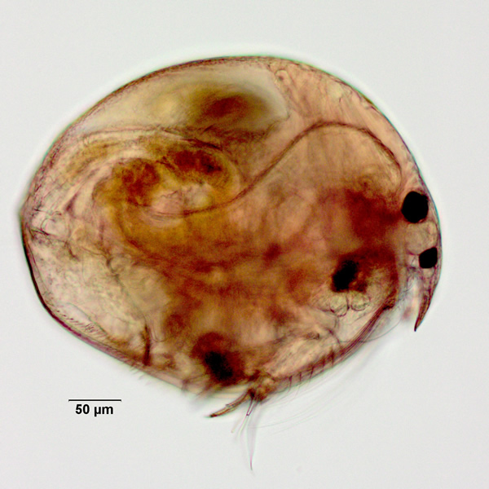 **Fig.3-4. A tiny “microcrustacean” zooplankton *Chydorus sphaericus* that is found in freshwater wetlands in the Americas, photo from** [**http://cfb.unh.edu/cfbkey/html/Organisms/CCladocera/FChydoridae/GChydorus/Chydorus_sphaericus/chydorussphaericus.html**](http://cfb.unh.edu/cfbkey/html/Organisms/CCladocera/FChydoridae/GChydorus/Chydorus_sphaericus/chydorussphaericus.html)

**Recombination** is the key here. This is when, during sexual production of gametes and formation of a zygote, portions of the two homologous (parental) chromosomes are swapped so that variation from those two chromosomes can end up next to each other (or linked variation on one chromosome may get separated). It can be fairly complicated, and can lead to very interesting patterns, but a basic representation of it is shown below along with a useful link if you want to learn more.

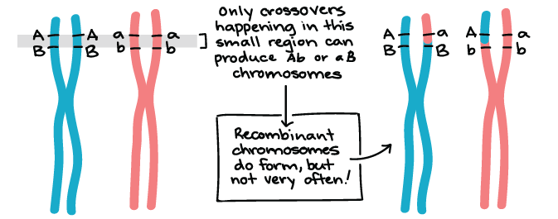 **Fig.3-5. A simple view of recombination between homologous chromosomes, not only is this a mechanism that adds overall diversity to genomes but it means that parts of a chromosome will have a distinct evolutionary/coalescent/mutational history than other parts of a chromosome, as shown at right.** [**https://www.khanacademy.org/science/biology/classical-genetics/chromosomal-basis-of-genetics/a/linkage-mapping**](https://www.khanacademy.org/science/biology/classical-genetics/chromosomal-basis-of-genetics/a/linkage-mapping)

I’m leaving this section short because you didn’t sign up for a genetics class 😄 Recombination complicates things in some ways, but it also helps us narrow the possible explanations for the data we see. Mathematically, it is complicated because it changes our bifurcating ‘trees’ expressing the coalescent history of a sample of whole chromosomes into a graph, where different portions of the DNA sequence *actually have different histories*. To the extent we recognize this, however, it means that distinct loci - whether SNPs obtained by RADseq (**BOX 1**), or allozymes (protein electrophoretic alleles), or sequences derived from targeted PCR fragments - are statistically independent views of the process of evolution in a population or set of populations, some of them influenced by effects on fitness or mate choice but most of them acting as independent observations of the process of genealogical descent and mutation (drift, coalescence). We can home in on a more accurate understanding of the history of a population when we have multiple loci.

## 3.3 The what-is-a-species problem

The fact I’ve brought up recombination means we have to recognize that most of the diversity we study is diploid (there are mechanisms by which haploid microbes and mitochondria, etc. also recombine diversity, however). It’s a fascinating transition because having two copies of each gene can tend to mask the negative consequences of an allele on one copy, or they can interact in evolutionarily interesting ways (Grosberg and Strathmann, “One Cell Two Cell Red Cell Blue Cell”, *TREE* 1998 doi: 10.1016/S0169-5347(97)01313-X.) This is where the fuzzy side of molecular ecology lies, because sometimes the diversity we are mapping across space and time will itself interact in interesting ways.

Earlier we mentioned “inbreeding”, which refers to closely related alleles (from closely related individuals) and may cause *inbreeding depression*, when those alleles combine to create a low-fitness phenotype. Remember, fitness is measured by survival and fecundity. Later in the book we will talk about conservation and management approaches based in molecular ecology methods and how they focus on adding diversity to populations and avoiding mating among related individuals.

There are plenty of reasons to categorize organisms and groups of organisms as ‘distinct’ (Chapter 4), and we now see that as more time *t* passes, portions of the genome become more distinct through mutation. When we study these divergent alleles using the models we have discussed, we will see in Chapter 5 just how they show that they cannot come from a single interbreeding population, and eventually we start talking about those populations being something entirely different: species.

When divergent chromosomes interact, the distinct mutations that have arisen may no longer interact well - they may code for proteins that don’t fit right, or change the timing of flowering or spawning (*phenology*) such that the combination creates offspring that have trouble surviving or reproducing. These interactions among very distant genomes are called *outbreeding depression*, again with a decrease in fitness. In fact, the greater the divergence between two genomes, or two populations, at this point it becomes more and more likely that such interactions will happen (Fig 3-6, Hudson Coyne Turelli; Plough)

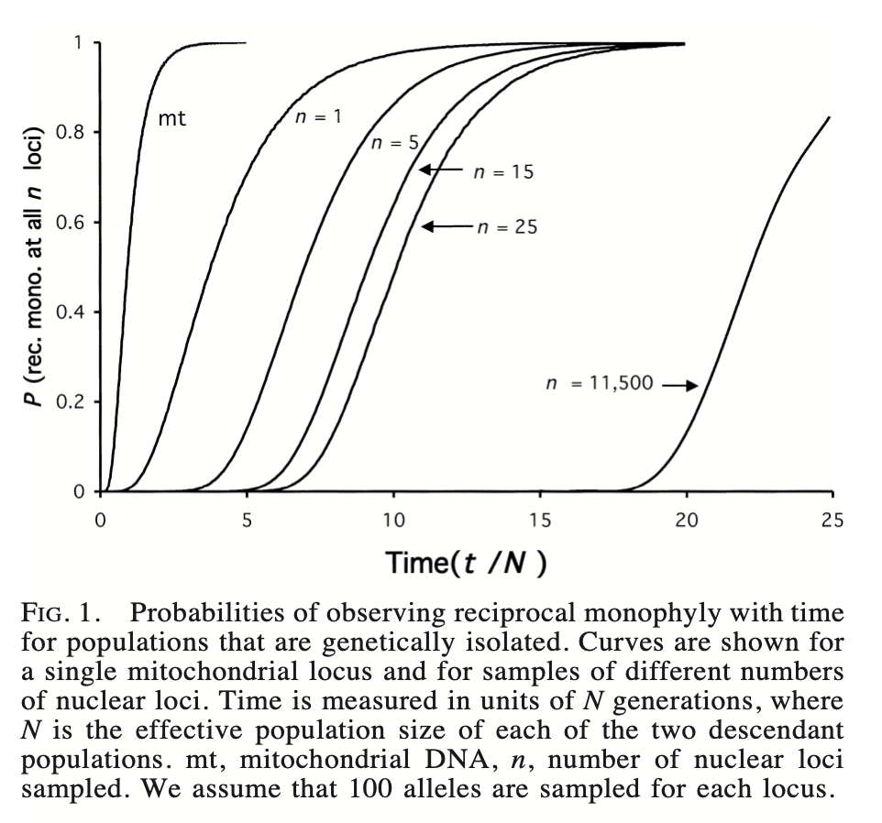 **Fig.3-6. The variable nature of how long it takes for diversity in 2 populations to have completely distinct diversity. The more loci being evaluated, the longer it takes for all of them to reach this status (in phylogenetic terms known as “reciprocal monophyly”). A mitochondrial locus is haploid and maternally inherited, so it has an effective *N* that is 1/4 that of a nuclear locus**

The figure above shows that with enough time, larger and larger portions of the genome will be distinct and that adds to the likelihood of outbreeding depression. The fact that crosses between two such populations have lower fitness is associated with speciation under what is known as the “biological species concept” (Mayr), but in our field we are more often diagnosing likely species based on genealogical or phylogenetic criteria, which are just as valid (de Queiroz 2007). The trick with drawing any hard and fast rule about “species” is that often there are counterpredictions, as wehn alleles that cause outbreeding depression (lower survival or reproductioh) vary among populations of the same apparent species and can even move between different apparent species when they do successfully hybridize (Sweigart). Divergence can also be significant simply because of differences in phenology (flowering, spawning, etc) times among populations, regardless of the fitness consequences of occasional crosses, or simple isolation - for many species we just don’t know what happens when they re-encounter one another.

A really fantastic example of this comes from Battey et al 2018, with one of the most gorgeous figures you will ever see in the field (Fig 3-7). This shows us how genomic diversity varies significantly among isolated populations of painted buntings on the east coast of North America versus those in central North America, with distinct migratory pathways and reproductive isolation based on where they return each year (R. Chandler: many neotropical migrants return each year within 50m of where htey were the previous year).

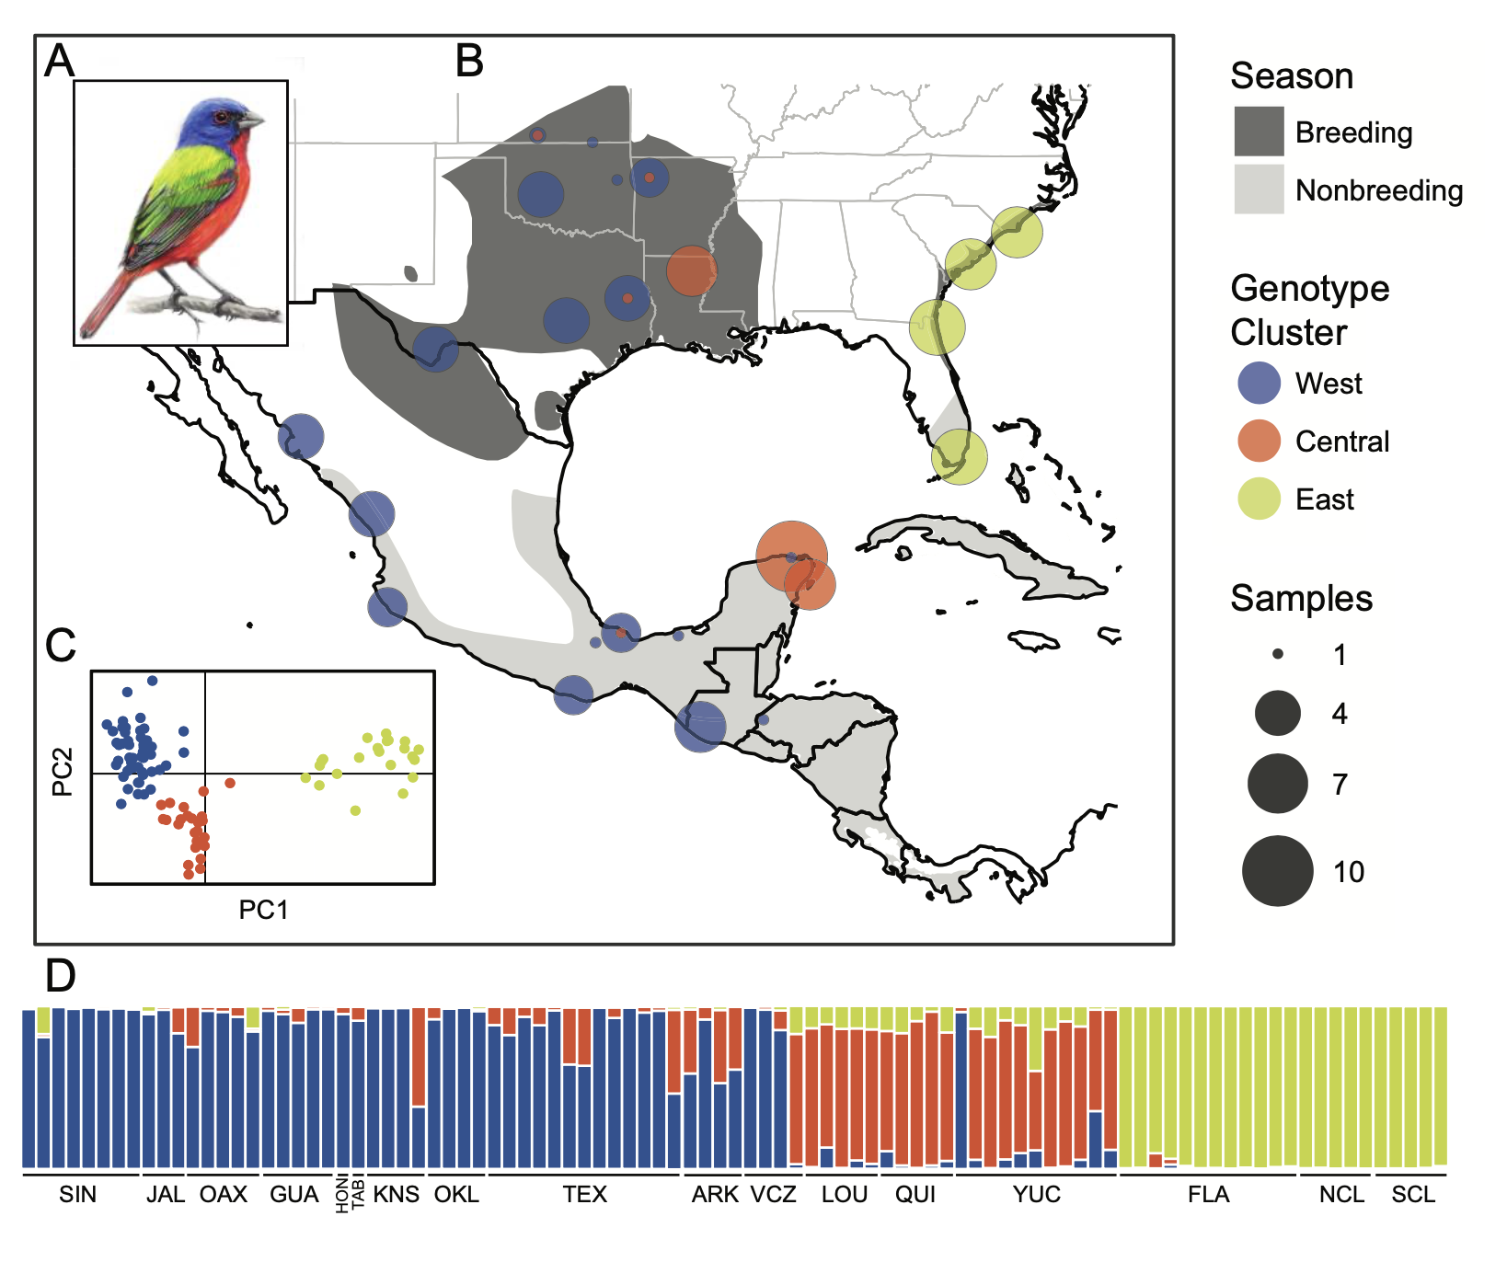 **Fig.3-7. Using single nucleotide polymorphisms (over 3600 of them!) Battey et al 2018 showed that the diversity separates the painted bunting *Passerina ciris* into 2 very distinct lineages and 3 evolutionarily distinct lineages based on the diversity among the sites shown. In later chapters we will talka bout the genetic as well as Euclidean models that let us separate samples of diversity this way. This is important because it not only highlights where there may be additional “species” within a single Latin binomial, but that there are ecological and management decisions to be made about how these distinct lineages migrate and overwinter.**

These data come from “genotype by sequencing” approaches, e.g RADseq or other methods (**BOX 1**). This means that individual single nucleotide polymorphisms (SNPs), analytically determined to be unlinked thanks to recombination, contribute to these patterns. However, as noted earlier *each individual SNP is only bi-allelic* and so contributes VERY little information about how these data fit a demographic or historical model that could be investigated with coalescent methods. The panel at the bottom (the bar graph) is actually generated by diploid genotype models discussed in the next chapter. The data involved are currently state-of-the-art and are beneficial in being so numerous (remember the advantage of independent views of evolutionary history thanks to recombination) but for many tests that we will consider later do not have sufficient information. The way that we will start to look at these unlinked SNPs will involve a more sophisticated set of summary statistics (site frequency spectra, genetic inheritance models, etc.) of DNA polymorphisms - more on this later (**Chapter 5**).

This is our big overview of how genomic data are used to explore the diversity of populations, and as you will soon see - mostly, the deviations from the *null models* that we assume. The next chapter will discuss how diversity within and among samples is evaluated and how using genomic data gives us an opportunity to establish these models so that we can see how mutational diversity can tell us about isolation among demes, changes in population size, selection, and nonrandom mating.

The diversity we are looking at starts to ‘feed back’ into generating functionally distinct things, in different habitats and environments, as it interacts with both environment and other alleles in the same organism - fitness consequences are a significant part of what sets the distribution and abundance of organisms. We will explore how small amounts of data are used to *predict* the isolation and status of distinct samples, but more data and experiments are often needed to identify outbreeding depression or other evolutionary effects (Hickerson et al 2006). As in Chapter 2, we are often starting from a question of whether or not it is *important* to characterize populations or locations as being distinct enough to merit further consideration.

**As an aside: it seems like I keep pointing the reader to information that is yet to come. I’m not sure if that is a weakness in the organization, or if it is recognizign that sometimes you need to be shown *why* you will want to know those details, and to set up a little bit of hunger for more. In the end, this may be the deciding factor in whether this text is useful for future classes or not, and I will appreciate your input. Personally, I like repetition and building-on-ideas; nothing in biology seems to be separate from other elements.**

Your reading for next week is to help us start to think about why some populations carry more mutational diversity than others - and it is often not described well by how many individuals there are. The “effective” population size I’ve alluded to describes how the population diversity *behaves* based on life history traits like male:female mating ratios, variation in reproductive success, and the history of a population, and becomes an important consideration in management and conservation as well as understanding the behavior of mutational diversity in a sample. So for next week read: Luikart et al (2010) *Conservation Genetics* **11**:355-373, linked on eLC. [*meh this wasnt’ best choice*]

**ASU students: I’m not only in the beginning of writing this, but had been writing it for a semester-long class with other papers to read etc, so pardon the typoes and odd references that aren’t needed for what we are doing at the moment!**